**Interactive Notebook For High School English 2**

**Lucas Moore**

**I am a teenager trying to find my place in high school and beyond.**

**I wonder what challenges I will need to overcome in order to obtain my dreams.**

**I hear myself thinking about if my work is good enough.**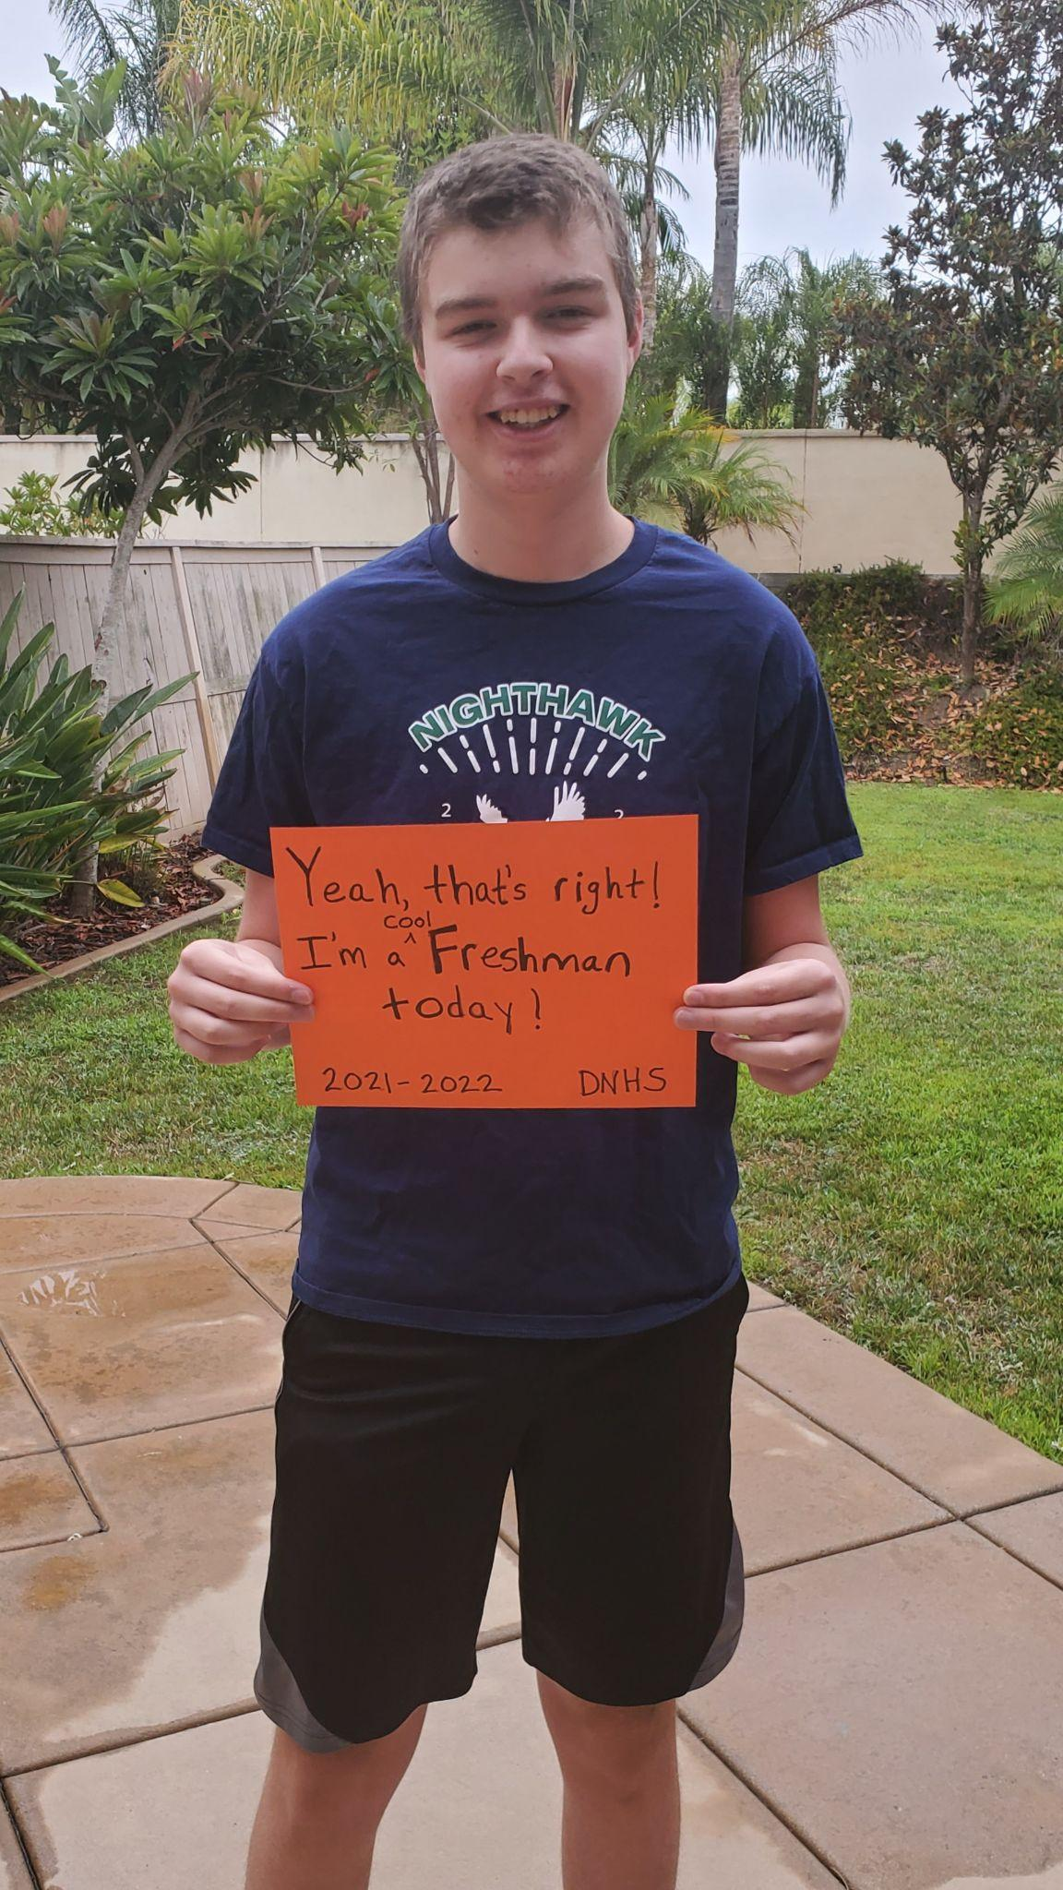

**I see myself trying and learning new experiences.**

**I want a bright and successful future.**

**I am a teenager trying to find my place in high school and beyond.**

**I pretend to understand what my Spanish teacher is saying.**

**I feel proud that I had good grades so far.**

**I touch my cellphone when I’m bored of studying.**

**I worry that this trimester will be harder than the last one.**

**I cry when I feel overwhelmed with stress about school work.**

**I am a teenager trying to find my place in high school and beyond.**

**I understand that honest and hard work is the best work to complete.**

**I say that I belong here in this school.**

**I dream of success and the feeling of accomplishment.**

**I try to make sure I have done everything right.**

**I hope it will be enough.**

**I am a teenager trying to find my place in high school and beyond.**

**Interactive Notebook Table of Contents**

Classwork/Homework l Journal Writing l Vocabulary Development

| Assign # | Date | Assignment Title |
| --- | --- | --- |
| 1 | 11/19/2021 | Course Description Questions |
| 2 | 11/18/2021 | Hero’s Journey Notes |
| 3 | 11/19/2021 | Jumping Mouse Hero’s Journey |
| 4 | 11/29/2021 | The Hero’s Journey Notetaker: Whale Rider |
| 5 | 12/1/2021 | Paragraph Brainstorming |
| 6 | 12/2/2021 | Hero’s Archetype Paragraph Outline |
| 7 | 12/7/2021 | Do Heroes Make Us Smarter Article |
| 8 | 12/8/2021 | Elie Wiesel and the Holocaust |
| 9 | 12/10/2021 | Gilmore Article |
| 10 | 12/14/2021 | Vera Atkins Article Close Reading |
| 11 | 12/16/2021 | The Gift of the Magi Close Reading |
| 12 | 1/3/2022 | New Year Better Me |
| 13 | 1/11/2022 | Romeo and Juliet-Background Notetaker |
| 14 | 1/12/2022 | RJ Viewing Notes |
| 15 | 1/18/2022 | Shakespeare's Language Notetaker |
| 16 | 1/19/2022 | Romeo and Juilet Prologue Notetaker |
| 17 | 1/21/2022 | Romeo and Juliet Act 1 Scene 5 Sonnet Close Read |
| 18 | 1/25/2022 | Wounded by my enemy Act 2 Scene 3 Close Read-Romeo and Juliet |
| 19 | 1/28/2022 | Love Evidence Sandwich-Romeo and Juilet |
| 20 | 2/2/2022 | Grief of Heart Act 3 Scene 5 Close Read-Romeo and Juliet |
| 21 | 2/8/2022 | Juliet Takes the Vial Act 4 Scene 5 Close Read-Romeo and Juliet |
| 22 | 2/10/2022 | Thus with a Kiss Act 5 Scene 3 Close Read-Romeo and Juliet |
| 23 | 2/10/2022 | Close Reading and Writing Practice Act 3 Scene 5-Romeo and Juliet |
| 24 | 2/14/2022 | Romeo and Juliet Has Led Us Astray |
|  |  |  |

**Class work**

Begin pasting in class work here. Make sure you title and # every assignment. Place assignments in reverse chronological order (most recent first)

Date: 11/19/2021 Assign# 3

**The Heroic Journey of Jumping Mouse**- Fill in the following chart with illustrations (you may use clipart) and a brief description of how the myth of Jumping Mouse demonstrates the stages of the Hero’s Journey. Include a label with your illustration and description, so that each part of the journey is clear.

| Act 1: Separation:   * Ordinary World * Call to Adventure * refusal of call * Assistance/ Meet Mentor | **Ordinary World:** The mouse lives and works in a grassland with other mice. However, the mouse keeps hearing a roar that other mice don’t, making him an outcast.  **Call to Adventure:** The mouse heards a roaring in the distance and goes to investigate it.  **Refusal of Call:** The mouse refuses to continue on the journey after the frog told him he needed to go in the water to get wet.  **Assistance/Meet Mentor:** The mouse meets the frog that tells him about the Sacred Mountains and gives him the strength to jump high and gives him the name Jumping Mouse. |  |
| --- | --- | --- |
| Act 2: Initiation:   * First Threshold * Road of Trials * Supreme Ordeal * transformation * Apotheosis | **First Threshold:** The mouse leaves home and walks to the river.  **Road of Trials:** The Jumping Mouse meets an old mouse, a dying buffalo, and a forgetful wolf that test how determined he is to get to the Sacred Mountains.  **Supreme Ordeal:** When the Jumping Mouse is blind and alone, he hears an eagle come up from behind.  **Transformation/Apotheosis:** The Jumping Mouse is reborn into an eagle. |  |
| Act 3: Unification   * Return Threshold * Elixor | **Return Threshold:** He doesn’t in this story.  **Elixor:** The Jumping Mouse is now an eagle. |  |

Hero’s Journey Archetype Notetaker Date: 11/18/2021 Assign # 2

| **Topic** | **Notes** |
| --- | --- |
| Archetype | Archetype is patterns that exist in all historic times and cultures. It is universal, making important parts for the story be more noticable. Makes people better understand the world and is entertaining. |
| Joseph Campbell | Joseph Campbell was a writer, philosopher, mythographer and he found out that all hero stories have the same pattern. He wrote the pattern in a book called “Hero with a Thousand Faces.” The pattern was a 17 stage journey called “The Hero’s Journey.” |
| Matt Winkler  TED Talk | * Hero’s Journey is a cycle. * **Steps:** Statue Que, Call to adventure, Help, Departing, Trails, Approach, crisis, treasure, result, return, New life, Resolution, Statue Que(Upgraded). * The Hero’s Journey happens to a person in everyday life. |
| Act 1: Separation | This starts in the ordinary world the future hero is in. During this stage, the hero gets a call to adventure. It could be a problem, challenge, or an adventure. Most of the time they refuse the call but may be forced. They then get help for the journey from a mentor. |
| Act 2: Initiation | The hero accepts the call to adventure and enters the new world. The hero gets tested in this world and then fights the biggest ordeal. After the fight, the hero transforms into a new person and has a new life. |
| Act 3: Unification | Returning from the new world and into the ordinary one. When returned, the hero gets their biggest reward and they share the hero’s reward/gift to change the world. |
| A look at *Mulan* | Ordinary world: Mulan doesn’t fit into her society.  Call to adventure: Her father is called to the military and knows letting him go will kill him.  Assistance: Her ancestors send Mulan a dragon.  Refusal to call: Mulan second guesses her choice but the mentor changes her mind and she continues.  New world: goes to the training camp.  Road of Trials: This is all the time she had at the training camp.  Supreme Ordeal: Fighting the Huns and being respected after being rejected when discovered.  Transformation: The journey shows who she really is and turns her into a better person.  The Road Back: goes home.  Elixir: Her father and family accept her for who she is.  New status quo: She is not afraid of her future. |
| Monomyth | Monomyth was made by Joseph Campbell and is the belief that many myths from different times and regions were structured the same way. The Monomyth is also known as the Hero’s Journey. |
| Christopher Volger | Christopher Volger is the author of “The Writer’s Journey.” He compares a writer’s journey to the hero’s journey and how they both experience the same stages of a journey. |

**Date: 11/15/2021 Assignment #1**

**HSE2 Course Description Questions**

**This will be included in your HSE2 Notebook Check #1 on Friday, November 19, 2021. For information about the notebook, check the daily agenda on Canvas (11/15).**

**.**

DIRECTIONS: Answer the questions in complete sentences.

1. What is your teacher’s email address? What is a second way that you can message her?

**Her email is rchristopher@powayusd.com. A second way is by directly messaging her in Canvas by using the inbox.**

1. What are the four possible units of study?

**The four possible units of study are: The Tragic Hero, THe Hero’s Journey and Hero Archetypes, Deserving Hero, and The Superhero Hero.**

1. Identify one higher level thinking skill, one reading comprehension skill, and one writing skill from the syllabus that you would like to work on this trimester? Explain why.

**A higher level thinking skill I would want to work on is evaluation because it would allow me to find better evidence in a text. A reading comprehension skill I would want to work on is visualizing in order to better understand the mood and tone of a text. A writing skill I want to work on is organization because I have a hard time having my thoughts flow well together in an organized way.**

1. Your teacher uses the weighted grade system. Within this system, what are the two categories and how are they weighted?**In the weighted grade system, summative work will count as 70% and formative work will count as 30% of my total course grade.**
2. Explain the bathroom pass and break policy. **With the bathroom pass and break policy, a student must sign out at the front of the room to get a hall pass from the teacher. Passes should be used only when needed and students should get back to class as soon as possible.**
3. What do you need to do if you are absent from class?

**Students will need to check the Canvas calendar for assignments if they are absent from class. If a student knows they are going to be absent, they have to come in the morning of a test or quiz or come to the tutorial the day before to take the test/quiz. If a student misses a class when there’s a speaking assignment, they may have a chance to make it up but it’s not guaranteed and you could lose points.**

1. Explain the late work policy in your own words.

**The late work policy for writing assignments means that you will lose 10 percent a day of total points, until they can be worth no more than 75%. Students have until the end of the unit to turn in late work and have a chance to get 50% credit if the work “meets standards.” If the standards are not met, the student will get a second chance to turn it in to meet the standards.**

1. Explain the culture of inclusion and equity.

**The culture of inclusion and equity means that you should treat everyone the same and treat everyone the way you want to be treated: with kindness and respect. We should all accept each other for who we are and it doesn’t matter their race, gender identity, sexual orientation, or religious affiliation.**

1. What is plagiarism? What steps can you take to avoid plagiarism?

**Plagiarism is when you use someone else’s work and claim it as your own for credit. Steps to take to avoid plagiarism would be to use quotation marks and give credit to the source/authors. Another way is to keep track of the resources or sites you use.**

**The Hero’s Journey: Whale Rider** Date: 11/29/2021 Assign #4

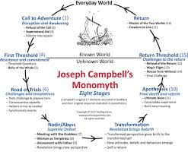

Notetaker

* Watch *Whale Rider*
* Look for the various stages of the Hero’s Journey.
* Take notes on the stages to prepare yourself for working with your group.

| Stages of the Hero’s Journey | Notes about plot and what happens in the movie |
| --- | --- |
| Ordinary World | In the ordinary world, Paikea is treated like an outcast towards most of the family because she is the only young girl. Her grandfather also doesn’t want her because he was expecting a grandson that would lead one day and thinks Paikea isn’t fit to lead because she is a girl. |
| Call to Adventure | Paikea starts to go to the airport that would take her to Germany. |
| Refusal of the call | Paikea looks at the ocean and sees a whale and decides to stay. |
| Meeting with the mentor | In order for her to get better at Taiaha, Paikea goes to Uncle Rawiri to practice and get better. |
| Crossing the threshold | Paikea participates in the trials that will determine the future chief. |
| Tests, Allies, and Enemies | | Tests | Allies | Enemies | | --- | --- | --- | | * Paikea swam deep in the ocean to receive the lost whale tooth. * Fighting Hemi with the talaha. * Speech | * Uncle Rawiri * Nanny * Hemi | * Koro | |
| Approach | Paikea called the ancients but then feeled that their responses were wrong. |
| Supreme Ordeal | Many whales were laying on the beach and were slowly dying. Paikea’s family tried to pull the leading whale back into the ocean but failed so Paikea rode on the leading whale into the ocean. This event almost killed her because she was thinking about accepting death. |
| Reward | Paikea lived and now has her grandfather’s respect and the idea that she would make a great leader. |
| The Road Back | Paikea floats off the whale and returns to the beach. |
| Resurrection | Paikea wakes up in the hospital to her grandfather. |
| Return with the elixir | Paikea now has her grandfather’s respect and the respect from others and she didn’t die. |



Paragraph Brainstorming Date: 12/1/2021 Assign#5

As a group, come up with at least four movies. Pick one of the stage’s in the hero’s journey and explain what happens in the movie. Pick one of the characters, identify the archetype and use evidence from the movie to support your opinion. See the sample for the *Wizard of Oz.*

| Movie Title | Hero’s Journey: state which stage & explain it in movie | Character Archetype: state archetype, state character’s name, and explain how he/she fits the archetype |
| --- | --- | --- |
| *Wizard of Oz* | Crossing the First Threshold- Dorothy lands in Oz and kills the Wicked Witch of the West with her house. She crosses from the ordinary world of Kansas to the magical land of Oz. | Hero = Dorothy, Dorothy longs for a different exciting life and is dissatisfied with her country girl life. On her quest to return home she makes sacrifices for her friends, experiences personal growth and gains wisdom from her challenges. She learns to appreciate and value her family and her ordinary life. |
| The Maze Runner | Crossing the First Threshold- Thomas enters the maze with Minho and Alby right when it closes and is stuck there for the night. He crosses from the ordinary world of the glade into the maze | Hero = Thomas, Thomas looks for a way out of the glade through the deadly maze and brings everyone out of the deadly maze and into the rest of the world. He sacrifices himself to find ways out and to save people. |
| Harry Potter and the Philosopher's Stone | Crossing the First Threshold - Harry crosses the first threshold into the wizarding world when he first enters Diagon Alley. This is where he first experiences meeting wizards, buying his first wand, and going to Gringotts Bank. | Hero = Harry Potter, the predominant persona in the series, represents the "hero" archetype. Harry in the sequence is the loved, successful, and morally straight personality that usually saves the day. He is an illustration of all the fine characteristics in our society: courage, intelligence, athleticism, and loyalty. |
| Spy Kids | Crossing the fist threshold: Carmen and Juni’s house get attacked and they escape in a submarine to a safe house. | Heroes = Carmen and Junie are two heroes that are unhappy with their life. Over the journey they both experience self growth by becoming more mature and bonding closer together, thus becoming content with their lives. |
| The Jungle Cruise | Supreme Ordeal- Lily, Frank, and MacGregor compete against Prince Joahim and his men and against the monsters for the last petal from the Tears of the Moon. | Mentor = Frank the skipper. When Lily and MacGregor cross into the jungle, they need someone to get them though the river. Throughout the movie, Frank also gives useful information about the monsters(the enemies) and helps them heavily in some of the trails. |

Hero’s Journey/Character Archetype Paragraph Date: 12/2/2021 Assign #6

**Writing a Two Chunk: Use this handout (it will ensure that you have all of the parts)**

**Support Thesis (aka Topic Sentence)-- i.e. In the movie __, the character __ becomes a hero when __ (one of the stages).**

In the movie *Wreck it Ralph*, the character Ralph displays the archetype hero when he faces obstacles that change and grow him as a person. Initially, Ralph is lonely, isolated, and misunderstood. He wants to be accepted and not seen as the bad guy anymore in his video game. He jumps into another video game to prove to everyone that he could be a hero by winning the prized medal. However, he ends up being transported to Sugar Rush Land where he meets Penelope. This is significant because Penelope plays a big part of Ralph’s evolution. She brings out traits and emotions in him that he never knew he had, such as: playfulness, protectiveness, love, and trustworthiness. She makes him realize that it’s better to have a true friend than a trophy.

**Lead-In AND Evidence/Concrete Detail #1 (you may paraphrase or quote the movie):**

During the climax of the movie, Ralph sends himself and hundreds of mentos into a volcano of hot coke knowing that it would kill him but would also end up killing the Cy-bugs that were terrorizing Sugar Rush.

**Commentary *(2-3 sentences in your own words! Why is the quote/example significant? What does it tell about your main topic/main thesis? How does this quote prove your topic sentence? “This is significant/important because…” “This shows that…” “This is because”)***

This part of the movie is important because it proves that Ralph is the hero. In a movie that uses the hero’s journey, the definition of a hero is the character that needs to overcome an obstacle that ends up changing the character. In the beginning of the story, Ralph was selfish because he only wanted a medal so that he could get the approval from his co-workers. However, later on, he realized that having true friends is better than approval and that it is better to actually be a better person. This heroic act of sacrificing himself for the greater good displays the role of hero.

**Lead-In AND Evidence/Concrete Detail #2:**

Another example of when Ralph represents actions of a hero is when he learned that Penelope’s racing could cause her to lose her life. In order for this to not happen, Ralph decided that the best course of action was to destroy her racing car.

**Commentary *(2-3 sentences in your own words! Why is the quote/example significant? What does it tell about your main topic/main thesis? How does this quote prove your topic sentence? “This is significant/important because…” “This shows that…” “This is because”)***

While this seems like a cruel act to do, he displays archetype hero traits of protection and love. Heroes often are faced with making hard decisions that may hurt people, but they do it with good intentions. Ralph destroyed Penelope’s car because he didn’t want to lose his only friend and would rather risk their friendship than her life. This is a selfless act often seen by archetypal heroes.

**Concluding Sentence**

In conclusion, Ralph is an archetypal hero in Wreck it Ralph because he evolves from being a self-centered lonely character to one that would sacrifice everything he values for the greater good.

**Do Heroes Make us Smarter Date: 12/7/2021 Assignment#: 7 Close reading practice**



| Article | Notes |
| --- | --- |
| Do Heroes Make Us Smarter?Heroes give us direction, wisdom, and emotional intelligence. By Scott T. Allison, Ph.D., *Psychology Today*, Apr 13, 2014  When legendary South African President Nelson Mandela passed away in 2013, the world responded with heartache mixed with reverence. President Barack Obama observed that Mandela “no longer belongs to us. He belongs to the ages.” With this statement, Obama illustrated what we have always done to our greatest heroes—we forge them in eternity.  Why do we idolize great heroic leaders? Obviously, heroes provide us with hope and inspiration. But my research on heroes reveals a surprising finding—they make us smarter, too. Heroes improve our intelligence about the world and teach us lessons about the trajectory of our own lives. Our research has uncovered four ways that heroes impart wisdom to us.  **1. Heroes teach us how to respond in crisis situations**  In 2007, Wesley Autrey, a construction worker living in Harlem, received international acclaim when he rescued a complete stranger from an oncoming New York subway train. Autrey witnessed the man fall on the subway tracks just as a train was approaching. Realizing he had no time to move the man from the tracks, Autrey made the remarkable decision to lie down on top of him in-between the rails as the train passed over them both. Only one-half inch separated Autrey from severe injury or death.  After performing this heroic act, Autrey received hundreds of letters from people thanking him for showing them how to live their lives and how to respond in emergency situations. Autrey and other selfless heroes like him teach us what to do, and the right thing to do, in challenging situations. Heroes like Autrey provide a script for heroic action to a world hungry for such a script.  **2. Hero stories illuminate paradoxical life truths**  Spiritual guru Richard Rohr argues that hero stories are saturated with complex life truths that are nearly impossible for humans to grasp unless they are illustrated inside a good hero story. Many of these truths are paradoxical secrets of human growth and development. For example, in a typical hero story, the hero cannot grow as a person until after he or she has experienced a significant falling or failing. “Where you stumble,” wrote comparative mythologist Joseph Campbell, “there lies your treasure.” Other paradoxical truths in hero stories include the wisdom that (a) we must leave home to find home; (b) we must lose ourselves in order to find ourselves; (c) we must surrender to win; and (d) we must give up something important to gain something important.  **3. Heroes teach us that their journey is the human journey**  Joseph Campbell believed that the Hero’s Journey parallels human developmental stages. All young adults are driven out of their safe, familiar worlds and into the fearful real world. Psychologist Eric Erikson’s stages of human lifespan development suggest a hero trajectory during our lives, with young adults driven to establish competencies and carve out an identity for themselves.  Older adults reach a stage of generativity, which Erikson defines as people’s desire to create things that will outlast them and to give back to the society that has given them so much. Hero stories teach us that we are all developmentally equipped to pursue a lifelong hero-like journey.  **4. Heroes help us develop emotional intelligence**  Psychoanalyst Bruno Bettelheim believed that children’s fairy tales are useful in helping people, especially children, understand emotional experience. The heroes of these fairy tales are usually subjected to dark, foreboding experiences, such as encounters with witches, evil spells, abandonment, neglect, abuse, and death. Listeners to these tales develop strategies for resolving their fears and distress.  Bettelheim believed that even the most distressing fairy tales, such as those by the Brothers Grimm, add clarity to confusing emotions and give people a greater sense of life’s meaning and purpose. The darkness of fairy tales allows children to grow emotionally, thus developing their emotional intelligence and preparing them for the challenges of adulthood.  **Conclusion**  Heroes give us far more than inspiration—they are our greatest teachers. Heroes show us the secrets to unlocking our fullest potential as human beings. They do so by role-modeling virtue, by clarifying complex and paradoxical life truths, by equipping us with emotional intelligence, and by revealing how their journey can be our journey, too. No wonder Obama said that Nelson Mandela “belongs to the ages.” The wisdom we get from our heroes has a timeless quality that helps us thrive as human beings. | Purpose: To have an historic detail that supports their argument and can be relatable.  Evidence: historic detail  Purpose: Transition to the main claim and state it.  Evidence: Research  Purpose: Provide a historic event as evidence.  Evidence: historic event  Purpose: To explain the importance of Autrey’s act.  Evidence: historic event  Purpose: To provide a sub-claim that supports the main claim.  Evidence: Expert opinion (Joseph Campbell)  Purpose: To provide another sub-claim that supports the main claim.  Evidence: Expert opinion (Eric Erikson)  Purpose: Explains how the sub-claim supports the main claim.  Evidence: Expert opinion (Eric Erikson)  Purpose: Proposes an idea that supports the main claim.  Evidence: Expert opinion (Bruno Bettelheim)  Purpose: Conclusions the idea that supports the main claim.  Evidence: Expert opinion (Bruno Bettelheim)  Purpose: To conclude the article by restating the sub-claims and the main claim.  Evidence: The whole article. |

What have you learned from the article?

What I learned from the article is that heros make us smarter because they teach us how to respond to a crisis, reflect real life truths and problems, relate to us by comparing a hero’s journey to a human’s, and by creating emotions that help us respond to certain situations.

What kind of text is this article?

This article is a narrative text.

What type of Evidence does the writer provide?

The writer provides expert opinions, historic events, and research.

How does this text add to your understanding of heroes and heroism?

The text makes me understand why most hero stories are made, the writers want the readers, watchers, or listeners to grow. Whether that be by teaching them about how to handle a crisis, think about life truths and problems, and/or grow emotionally.

Based on this article, why do you think the hero’s journey appeals to the human psyche?

Based on the article, the hero’s journey appeals to the human psyche because humans want to leave something behind when they are gone and the hero’s journey's most common reward is being remembered for something great. That is just what humans want.

Give an example of someone who you believe is heroic and how this person has guided you.

I believe that both my parents are heroic because they have put me before themselves. They have guided me to becoming a better person by making me more selfless.

**Elie Wiesel and the Holocaust Date 12/08/2021 Assignment 8**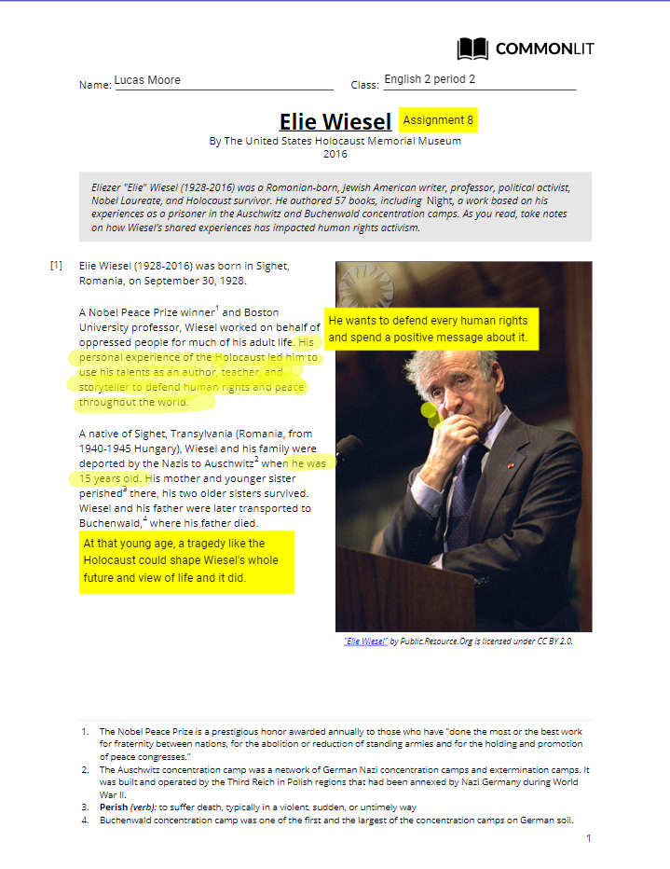

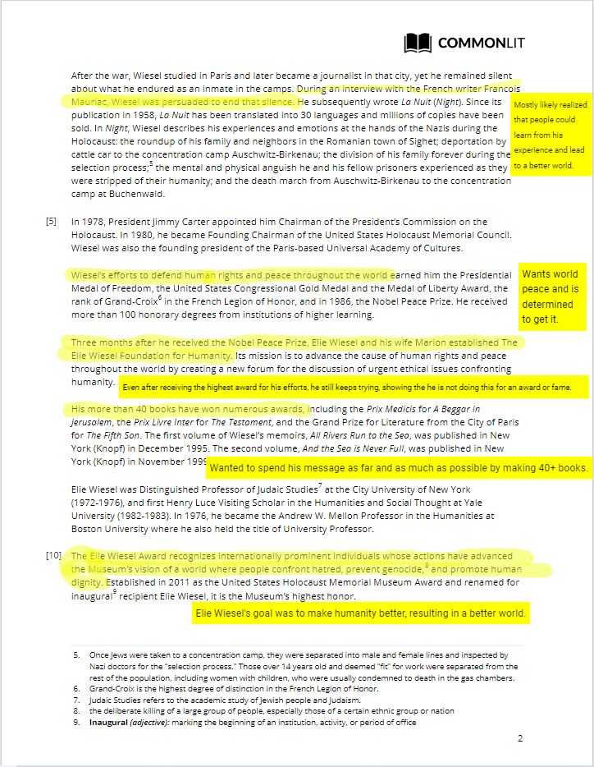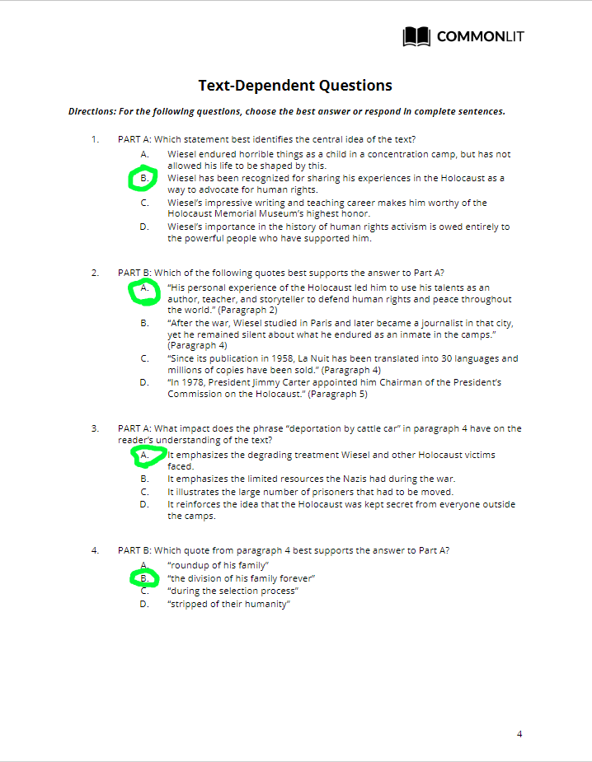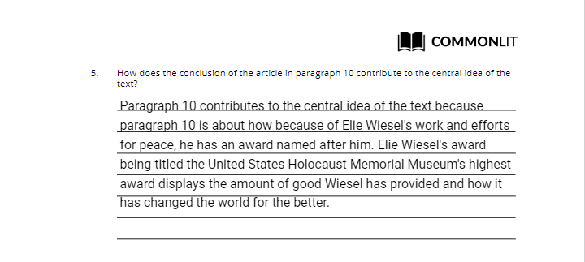

**Gilmore Article Date 12/10/2021**

**Assignment 9**

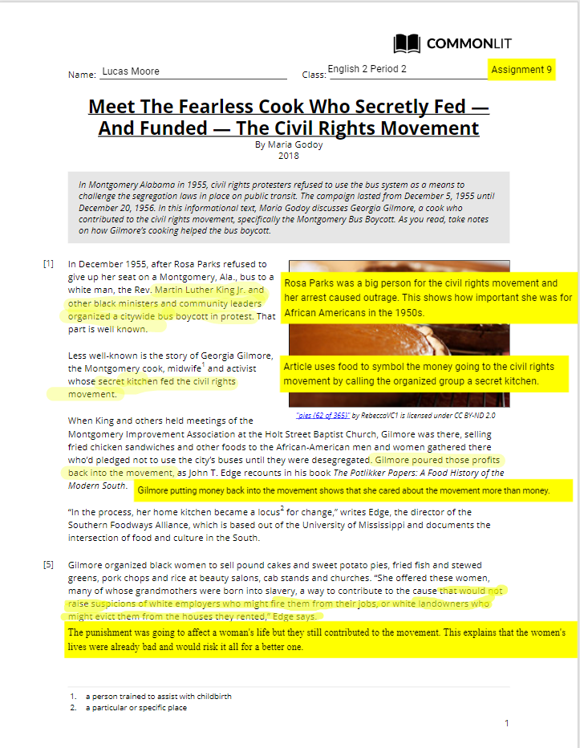

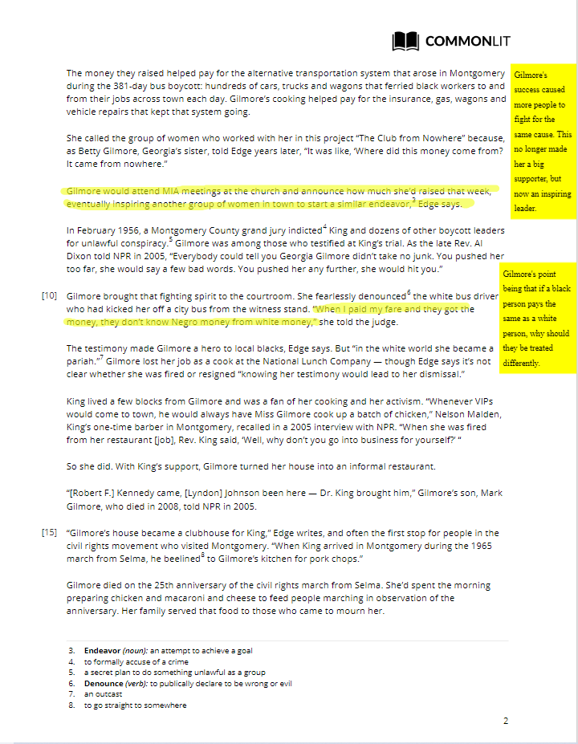

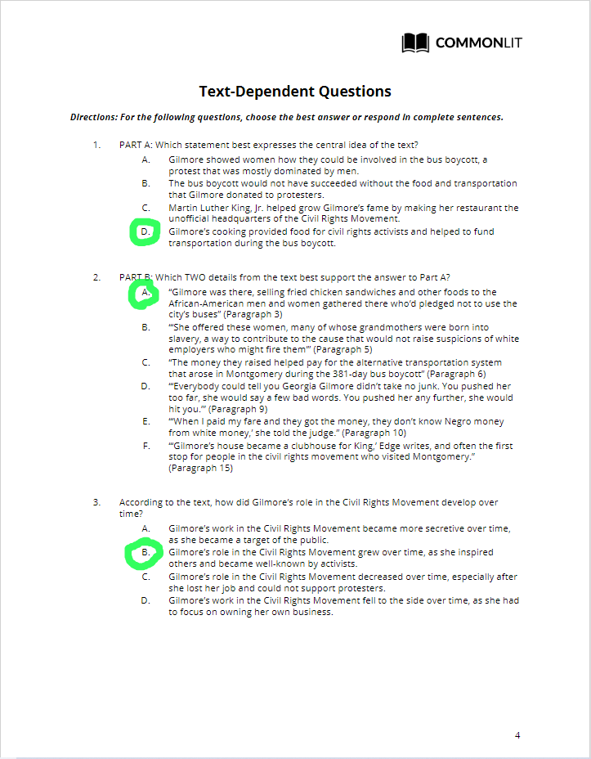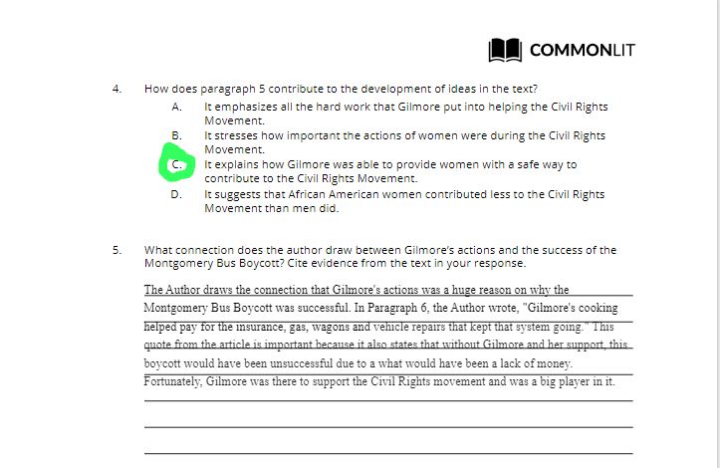

**Vera Atkins Article Close Read** Date: 12/14/2021 Assignment#10

Close reading directions: Today you will practice close reading skills. Remember these skills will help you develop your comprehension skills. You will complete the “before you read” activities above the article and the “during the reading” annotations will be to the right of the article.

Before you read: Answer the questions in red before you read the article.

* Set a purpose for the reading. Establishing a purpose will help you focus. WHAT IS YOUR PURPOSE FOR READING? **My purpose for this reading is to practice my close reading skills from learning more about Vera Atkins and how she contributed to WW2.**
* Preview: look through the work. Look at the headline or title. Read the subheadline. PREDICT WHAT THE ARTICLE WILL BE ABOUT. **The Article will most likely be about Vera Atkins’s life story, how she contributed to WW2, how she survived as a spy, and her death in 2000.**
* **Connect** the subject matter to what you already know. WHAT DO YOU ALREADY KNOW THAT WILL HELP YOU COMPREHEND THIS ARTICLE? **I already know that Vera Atkins was a British intelligence officer, worked for the France Section of SOE for 4 years, and interrogated nazis to find out what happened to 14 of her agents.**

During the reading:

* **Check for understanding**. Can you restate/**summarize** it in your own words?
* **Connect** what you are reading to your own life and experiences.
* **Question.** What is the writer's purpose? What type of evidence is being provided? What is the message/claim?
* **Clarify** your understanding. Write down your opinion or thoughts about the work.
* **Evaluate** the writing. Evaluate the writer’s ideas and reasoning. What type of evidence does the writer provide? Think about types of evidence: historic details, expert opinion, facts/statistics, etc. Is the evidence effective? Has the writer supported their claim? How? How well?

# ***Vera Atkins, 92, Spymaster for British, Dies***

**By** [Douglas Martin](https://www.nytimes.com/by/douglas-martin) published in the New York Times, June 27, 2000

| **Article** | **Annotations** |
| --- | --- |
| Vera Atkins, who recruited, trained and watched over the legendary British secret agents who parachuted into France to sabotage the Nazis in World War II, died on Saturday in Hastings, Sussex. She was 92.  Although Ian Fleming never identified her, Ms. Atkins was widely believed to have inspired the character of Miss Moneypenny in the James Bond series. She was principal assistant to Col. Maurice Buckmaster, director of the Special Operations Executive, who is said to have been the model for ''M.''  But Ms. Atkins's steel-trap intelligence and fierce loyalty to agents who had been warned their chances of surviving were barely one in two were a far cry from Miss Moneypenny's lovestruck mooning over the elusive Bond. Ms. Atkins's heart was with her 400 secret agents. She stood on the runway to watch each take off to parachute into France.  After the war, when the tally of lost agents turned out to be a little worse than 1 in 4, Ms. Atkins pushed to be assigned to investigate each of the 118 cases. She traced 117, all dead, and brought their surviving killers to war crimes trials. The 118th had been, unknown to her, a compulsive gambler who vanished not far from Monte Carlo while carrying three million francs of secret service money.  ''I could not just abandon their memory,'' she said. ''I decided we must find out what happened to each one, and where.''  She spent nearly a year questioning officers from concentration camps and poring over records. ''I was probably the only person who could do this,'' she said. ''You had to know every detail of the agents, names, code names, every hair on their heads, to spot their tracks.''  The confessions she obtained from the Auschwitz commandant, Rudolf Hoess, were used as evidence at the Nuremberg Trials. She always shuddered at Hoess's reaction to her suggestion that 1.5 million people had been killed in Auschwitz.  ''Oh no,'' he said, as if offended. ''It was 2,345,000.''  Ms. Atkins was born Vera Maria Rosenberg in Bucharest, Romania, and went to London with her parents in 1933, where she adopted her mother's last name. She studied modern languages at the Sorbonne and went to finishing school at Lausanne. Her perfect French and her just as perfect manners would come in handy later.  At the outbreak of the war, she joined the Special Operations Executive, which Winston Churchill set up ''to set Europe ablaze'' through sabotage and subversion. The unit started slowly. But after victory in Europe, Dwight D. Eisenhower said, ''It was the equivalent of 15 divisions.''  Hitler said, ''When I get to London I am not sure who I shall hang first -- Churchill or that man Buckmaster.''  Hitler, perhaps, did not know about Buckmaster's assistant, Ms. Atkins.  The spymasters headed the unit's F section, for France. They began by interviewing candidates in a hotel room with a desk, two chairs and a lightbulb. After the initial questioning, they had a general conversation in French to see whether the applicant could pass as a native. Each successful candidate was told that he had a 50-50 chance of survival and given a few days to think about it.  The recruits were a remarkable cross-section -- bankers and playwrights, chefs and taxicab drivers. Gen. Charles de Gaulle had insisted that the unit not recruit French citizens, while demanding that he control the agents. Most of those selected were half-French British citizens.  The initial training was at a 16th-century country house where they had no contact with the outside world. Next came a commando course in the Scottish Highlands, where they learned about guns and explosives. Then there was a survival course in Hampshire, followed by parachute training near Manchester.  They were given practice in being interrogated and keeping up their cover stories by going over and over their false identities and backgrounds.  It was Ms. Atkins who briefed the agents in minute detail on how to live in occupied France with its curfew and regulations. They were given continental clothing and French mementos, ticket stubs, letters and keepsakes to put in their pockets.  At last, they were dropped in France, to be met by reception committees. Each evening, they received their orders in coded personal messages broadcast after the news on the BBC French Service.  Ms. Atkins had no rank, but the blunt force of her personality, described by The Times of London as a ''sledgehammer,'' pervaded the operation. She worked 18-hour days. A British television documentary in 1997 reported that she sent off each agent with the brisk shout of a French expletive.  One agent, George Millar, recalled in his autobiography, ''Road to Resistance,''( Little, Brown, 1980), how she had reacted to his falling in love -- again. ''Oh, the bloody English!'' she said. ''We never have bother of this sort with the French. They just copulate, and that is that.''  Usually she remained in the shadows. But the accounts of some heroes whom she controlled eventually came to the fore. Four agents were captured separately, given fatal injections and burned in ovens. Violette Szabo, who was tortured and shot, became famous. So did Odette Sansom, who refused to talk even when the Gestapo pulled out her toenails one by one. She was the first woman awarded the George Cross and was the subject of a 1951 movie that took its title from her first name.  Ms. Atkins, who did not marry and has no known survivors, worked to keep the memory of the Resistance alive. She was appointed a Commandant of the Legion of Honor in 1987.  She traveled a great deal, but settled in a cottage left her by an aunt at Winchelsea, from which, on a clear day, you can see France.  ***Editors' Note:*** *July 14, 2000, Friday An obituary on June 27 about Vera Atkins, who recruited and trained British secret agents sent to France in World War II, reported on her education and upbringing, the methods she used to help train the agents and her intense loyalty to them. The 1,000-word article was based substantially on The Times's research in books, but some information came as well from The Times of London and other British publications. Five brief passages in the obituary closely reflected the phrasing of an obituary in The Times of London. These were references to Ms. Atkins's background, to her attempts to trace missing agents, to the training regimen for agents and to Ms. Atkins's retirement. Although the London paper was cited as a source for some material, those five passages should also have been attributed to it, or should have been rephrased.*  ***Editors’ Note:******July 14, 2000***  *An obituary on June 27 about Vera Atkins, who recruited and trained British secret agents sent to France in World War II, reported on her education and upbringing, the methods she used to help train the agents and her intense loyalty to them. The 1,000-word article was based substantially on The Times's research in books, but some information came as well from The Times of London and other British publications.*  *Five brief passages in the obituary closely reflected the phrasing of an obituary in The Times of London. These were references to Ms. Atkins's background, to her attempts to trace missing agents, to the training regimen for agents and to Ms. Atkins's retirement. Although the London paper was cited as a source for some material, those five passages should also have been attributed to it, or should have been rephrased.* | Vera Atkin was a hero and now she is dead.  While Ms Atkins may have inspired the character of Miss Moneypenny, Ms Atkins steps into the action when needed.  Ms. Atkin shared her heart with all her agents, not just one.  <--This paragraph connects to the fact that Ms. Atkin cares about all her agents. She pushed herself to find the missing ones, even most likely knowing that they were dead.  Historic figure, a very effective piece of evidence because it is coming from the person the article is about.  Ms Atkin’s way of growing up made her have the tools needed for her future work.  The evidence coming from a historic figure explains that the special operations could be a success.  Even through Hitler didn’t know about Ms. Atkins. She was a big help in stopping his progress.  This was the agent’s tests and the agent’s rank.  The fact that she had no rank shows that Ms Atkins was dedicated to her work even if she was overshadowed.  Historic figure, an effective piece of evidence because it is coming from one of the Ms. Atkins’ agents.  Ms. Atkians didn’t want her agent's lives to go to waste. |

**Questions:**

What is the writer's purpose?

The writer’s purpose is to inform the reader of who Vera Atkins was and why she is a person worth remembering.

What type of evidence is being provided?

All the evidence provided in the actile is from a historical figure that was important in world war 2 or had something related to Ms. Atkins.

What is the message/claim?

The message of this article is that Vera Atkins’ life of work and determination was a big help for the British during world war two and is worth remembering.

The Gift of the Magi Date: 12/16/2021 Assign#11

Reading Comprehension Guide

**BUILDING BACKGROUND:**

Read the “Build Background” paragraph on slide two and explain O’Henry’s allusion to the Magi.

| Answer here: O’ Henry’s allusion to the Magi is the three wise men giving Jesus gifts with great value. |
| --- |

**LITERARY TERMS**: For each term provide an example from the story. Fill in the plot diagram to show your understanding of a traditional plot structure.

| Literary Term | Include an example from the story. Cite the page # after the quote. |
| --- | --- |
| Setting | “She(Della) stood by the window and looked out dully at a gray cat walking a gray fence in a gray backyard.”(page 2) |
| Simile | “Jim stopped inside the door, as immovable as a setter.”(Page 3) |
| Metaphor | “Which instigates the moral reflection that life is made up of sobs, sniffles, and smiles, with sniffles predominating.”(Page 1) |

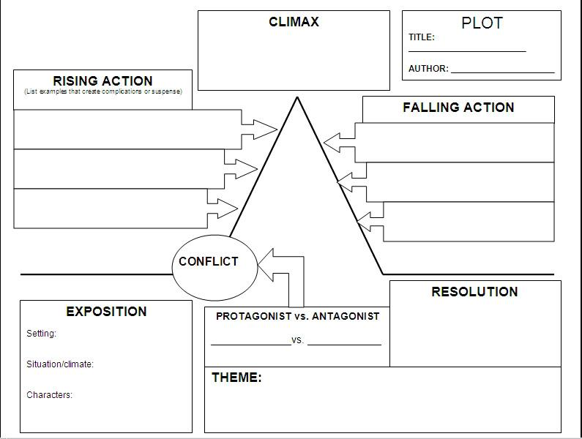 **Down Below**

**Plot Diagram**

| **Plot Structure or Device** | **Explanation of what happens in the text** |
| --- | --- |
| Exposition | Della and Jim are husband and wife and both are low on money for Christmas presents for each other. Della’s most valuable object is her hair and Jim’s most valuable object is his watch. |
| Rising Action | Della sells her hair in order to have enough money for a Christmas present for Jim. |
| Climax | Della and Jim give each other their gifts. |
| Falling Action | Both realize that they can’t use each other’s gifts because they needed to sell the watch and the hair in order to buy the gifts in the first place. |
| Resolution | They put the gifts away and start getting ready for dinner. |
| Protagonist | Della and Jim. |
| Antagonist | Lack of Money from Christmas presents. |
| Internal Conflict | Both Della and Jim sell their most valuable possessions for each other. |
| External Conflict | Della and Jim try to get a Christmas present for each other. |

**Situational Irony—**The difference between what is expected to happen and what exists or actually happens is called irony. The most common kind of irony is situational irony, which occurs when a character—or the reader—expects one thing to happen but something entirely different occurs. Use the chart below to explain situational irony in “The Gift of the Magi.” For each character, identify what is expected to happen and what actually happens.

| What Della Plans:  To buy Jim a chain for his watch as a Christmas present. | What actually happens:  Jim sold his watch in order to buy Della a Christmas present. |
| --- | --- |
| What Jim Plans:  To buy Della combs for her hair as a Christmas present. | What actually happens:  Della sold her hair in order to buy Jim a christmas present. |

**Allusion**—Explain each of the allusions in the text. Explain what the allusion is and how it contributes the story. Write in complete sentences.

| Allusion | What is it? | How does it contribute to the theme of the story? |
| --- | --- | --- |
| Queen of Sheba | The Queen of Sheba is a woman from the Hebrew bible who brought valuable gifts for King Solomon. | This contributes to the theme of the story because Della is saying that her hair is a better gift than all her gifts to King Solomon. |
| King Solomon | King Solomon is a man from the Hebrew bible who received gifts from the Queen of Sheba. | This contributes to the theme of the story because Jim is saying that his watch is better than all of the King’s gifts. |

**QUESTIONS**: Answer the following questions in complete sentences.

1. **How much money does Della have?**

Della had $1.87.

1. **What did Della want to do with the money?**

Della wanted to use her money to buy her husband a Christmas present.

1. **What 3 words would you use to describe Jim and Della’s relationship?**

Jim and Della’s relationship was loving, most valuable, strong.

1. **What has happened to Jim’s weekly salary?**

Jim’s weekly salary shrunk from $30 to $20.

1. **What are the two possessions that Jim and Della take a lot of pride in?**

Two possessions that Jim and Della take a lot of pride in are Jim’s watch and Della’s hair.

1. **What two gifts do they buy each other?**

Jim buys Della hair combs and Della buys Jim a chain for his watch.

**THEME**

Look again at the title of this story. What “gift” do you think O’Henry had in mind? How might it suggest a theme of the story? Please write 3-4 complete sentences explaining what you think the theme is and why.

| The Theme of the *Gift of the Magi* is love and how it is the most important valuable of them all. At the end of the story, the readers learn that both Jim and Della sacrificed their greatest valuables for each other; “two foolish children in a flat who most unwisely sacrificed for each other the greatest treasures of their house”(Page 5). Both their actions show that they value each other rather than an object and that their love is the best gift to give. |
| --- |

**SETTING and MOOD**

The author’s careful rendering of setting—and mood—help the reader understand just

how big the sacrifices Della and Jim make are when they sell their most prized possessions. Provide a quote from the story that provides details about the setting. Include page number. Highlight the words that set the tone and explain the quote. What does it describe? How does this help the reader see that both characters are indeed sacrificing? Need a review look back on our [suspense and horror slideshow](https://docs.google.com/presentation/d/1yE85YEtlQPKA3dLdkP3BtCHO70G7kbxbIQH5HNNX0qY/edit?usp=sharing) slide 13

| **Quote from the text + page #** | **Explanation. Write in complete sentences.** |
| --- | --- |
| “She(Della) stood by the window and looked out dully at a gray cat walking a gray fence in a gray backyard.”(page 2) | The quote at right explains what the neighborhood around Della feels like and her living condition. In this case, the color gray represents dull, sad, and/or nothingness based on Della’s reaction to the world around her. The quote describes the neighborhood and how it feels worthless and unhappy. This quote also shows that both Della and Jim were sacrificing so much. Based on where the two lived, they had little to nothing to their name which strengthens the importance of them sacrificing their greatest values for each other. |

**New Year, Better Me Date: 1/3/2021 Assignment: 12**

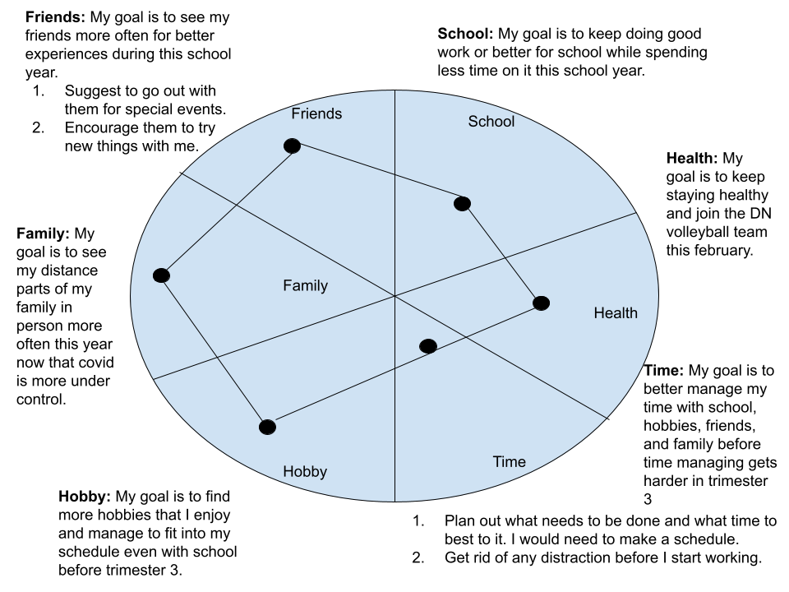

**1. After looking back on last year and setting goals for this year, were you surprised by anything? Explain.** I am surprised how much time has passed since I saw distant parts of my family and even some of my friends. I do not see my distant families a lot but covid made the wait much longer and noticeable.

**2. What can you do to make sure you follow through on your goals and objectives?** I can make sure I follow through my goals and objectives by having daily reminders on my phone or notes around my house. Those reminders could also include information on the benefits of completing my goals and objectives.

**3. On the bottom of the page, draw your name in a circle… create a bubble cluster showing all of the people in your life who will support you with these goals (family, friends,**

**coaches, teachers, neighbors, etc.)**



***Romeo and Juliet*-- Background Notetaker Date: 1/11/2022 Assign# 13**

As you listen to your teacher and watch the videos, take notes on information that stands out to you.

| Topic | Notes |
| --- | --- |
| Elizabethan | Refers to a historical time period to England when Queen Elizabeth Tubor was in control. During this time(16 century) the economy boomed because of the new middle class trading and London’s population increased greatly. |
| Elizabeth (1) | * Queen Elizabeth Tubor was the first female monarch and the Elizabethan time period was named after her. * Loved Music, dancing, pageantry, and masques. * Because of the atmosphere the queen created, many artists flourished in their work. * Elizabeth changed England from a torn country to the strongest country in the world by the time of her death. |
| Shakespeare | * Lived 1564-1616. * Born Stratford-Upon-Avon. * Wrote 37 plays:   + 10 tragedies   + 17 comedies   + 10 histories * Wrote 154 sonnets. |
| Attending a play at the Globe | * Open air theater * Can hold 3,000 people * The play was also a time where people could flex their wealth. * Price:   + 1 penny: To get in the theater.   + 2 pennies: To get a seat with a roof.   + 3 pennies: To get a seat with a roof and a more comfortable seat. * Boy actors would also play girls. |
| The Globe | * Where Shakespeare wrote, directed, and acted. * Lord Chamberlain's Men was the acting company. * All the actors needed to shout and over act their part. * Actors practiced their lines for 3 hours for a 2 hour play. * The theater was burned down in 1613. |
| Pre Show Talk | * A couple that was always apart, like today’s quarantine * This is a love story surrendered by hate. |
| Crash Course Romeo and Juliet | * Shakespeare didn’t make Romeo and Juliet but made it a more complex story. * The deaths of the two lovers were caused by their love blinding their fate and their family problems. * Both Romeo and Juliet committed suidede after seeing each other “dead.” |

**Watching Shakespeare’s Globe’s Production of *Romeo and Juliet***

***Assignment: 14 Date: 1/12/2022***

As a preview to our reading, we will watch the entire play this week. It is almost 3 hours, so this will be your only essential assignment this week. This is a classic version of the play performed on stage at the Globe theater in London. As you watch, please complete the chart before. **To provide guidance and to help you, some of the boxes are completed in green below. You do not need to write in complete sentences. You may use bullet points and make a list. Do not use green USE black or any color other than green. Due when we finish watching.**

|  | **Plot and Conflict** | **Themes** | **Characters** | **Staging** |
| --- | --- | --- | --- | --- |
| Act I  (0:00-36:17)  Wednesday | * Montague and Capulet servants fight- external conflict * Romeo depressed over Rosalind not loving him * Romeo and Juliet meet and share their first kiss * The Capulets want Juiltet to marry in the prince’s family for royal power against the Montague. | * Love (star-crossed lovers) * Hate (consuming feud between families) * Fate (control vs. lack of control) * Loyalty (to family, to the prince) | * Benvolio: A Montague who is friends/cousins with Romeo and is trying to guide him during his young age. * Prince Escalus * Capulet(Juilet’s father) * Romeo: A Montague who is young and wanting love. * Juliet: A Capulet who is coming to the age of marriage. * Nurse: A Capulet who is a nurse to Juliet and acts like a second mother. * Lady Capulet: A Capulet who is Juilet’s mother and is planning to get her daughter married. | * Drums play during the sword fights. * Peaceful and Cheerful music plays during the party to represent a happy time. * The actors coming out from our left to the stage represent people entering the scene. * The actors going out of the stage to the right side represent them leaving the scene. |
| Act II  (36:17-1:14:09)  Thursday | * Romeo goes to meet up with Juilet again. * Juliet is in love with Romeo, but she is concerned about how quickly their love is going and how the family's conflict might stop their love. * Romeo and Juliet marry. | * Impulsive decision making * Love (and worried about hate) * Quick/reckless marriage. | * Juliet has strong feelings that she battles * Romeo wants her to commit quickly * Romeo and Juliet have different ideas on the hasty nature of their love * Friar Laurence(Is trusted by Romeo by telling him about Romeo and Juliet.) * Friar Laurence marries Romeo and Juliet. | * Music plays to the mood of the situation. * Delightful music plays after Juliet hears she is going to marry Romeo. |
| Act III  (1:14:10-2:00:12)  Friday | * Tybalt kills Mercutio * Prince banishes Romeo * Romeo and Juliet spend a final night together * Romeo kills Tybait. * The death of Tybait straightens the hatern between the two families. | * Life after being removed from your family. * Having a secret affair and going to marry again. | * Juliet is shamed and now unloved by her father after telling him that she doesn’t want to marry Paris. * The nurse is convincing Juliet that Romeo is a lost cause and that marrying Paris is the only way she can be happy. | * Heavy drumbeat music powers the fight scene and heightens the intensity in the theatre * Characters travel the full distance of the stage, rolling, tumbling, while interacting with elements of the stage |
| Act IV  (2:00:12-2:24:30)  Monday | * Conflict within Juliet increases because of the impending marriage to Paris. * Juliet begs Friar Laurence to help * Together they set up a plan to keep Juliet from marrying Paris | * Fate vs. Freewill * Communication-- miscommunication as a result of secrets and deceit * The power of love | * Friar Laurence sets up marriage to Paris * Capulet and Lady Capulet are pleased their daughter is obeying their rules * Juliet follows Friar Laurence’s plan | * Eerie music plays as Juilet is about to drink the sleeping potion. * Peaceful music plays to represent Juilet’s peaceful “death.” * Slow and quiet music plays as the sleeping Juilet is carried out of the theater. |
| Act V  (2:24:30-2:51:00)  Monday | * Characters become aware of the events of the previous acts * Characters try to take control of actions but see the role fate plays in their situation | * Sacrificing for love. * Peace after war. * Where people go after death. Refers to the heavens. | * Romeo kills Paris. * Romeo and Juilet killed themselves after seeing each other “dead.” Romeo with poison and Juilet with a dagger. | * The use of verticality to separate the scene into its key elements * Physical motion through the scene adds a heightened sense of emotion |

*Romeo and Juliet*-- Language of Shakespeare Date: 1/18/2022 Assign# 15

As you listen to your teacher and watch the videos, take notes on information that stands out to you.

| Topic | Notes |
| --- | --- |
| Poetry versus prose | * Poetry has regulated line length * Most of the time Poetry has a meter. * Prose is just everyday writing |
| Meter | * The beat or rhythm in poetry. * Meter can be determined by stressed syllables that determine how loud sounds or how soft sounds are. |
| Iamb/Iambic pentameter | * Iambic is a meter used as an adjective. Mostly to describe ourselves or other people. * Line length is the length of the line. * 5 feet= pentameter. * Iambic pentameter is also called the heartbeat rhythm because the lines sound like the heart beating. * The opposite of an iambic meter is a trochaic meter. * U / U / U / U / U /   And I / will make / thee think / thy swan / a crow |
| Blank Verse | * Blank Verse is an unrhymed iambic pentameter. * Shakespeare uses this the most. |
| Couplet | * Couplet is a rhymed iambic pentameter. * “Compare l her face l to some l that I l shall show,   And I will make thee think thy swan a crow” |
| Prose in Shakespeare | * Normal talking in a poem. * “Do you bite your thumb at us, sir?   I do bite my thumb, sir.  Do you bite your thumb at us, sir?” |
| Why is it important to understand Shakepeare’s language and the way he constructs his lines? | Understanding Shakespeare's language is important because it would help someone read the play and understand who is who based on what verse they use. |

*Romeo and Juliet: The Prologue Date: 1/19/2022 Assign # 16*

**Directions:** Before you read “The Prologue” choose one of the words below and learn the definition. Add the word to the vocabulary section of your notebook.

| * Dignity * grudge * mutiny: a rebellion that is against authorities or something or someone else with higher power. | * civil * Star-crossed * Misadventured |
| --- | --- |

**Complete the following:**

1. **Label the quatrains and the couplet.**
2. **Label the rhyme scheme**
3. **Label iambic pentameter in the first 2 lines of quatrain 1.**
4. **In the right column, define words you don’t know. Look up allusions and imagery. Take notes about your understanding of what the words mean.**

| **Chorus**  **Quatrains 1:**  **U / U / U / U / U /**  Two households both alike in dignity, a  **U / U / U / U / U /**  In fair Verona where we lay our scene, b  From ancient grudge break to new mutiny, a  Where civil blood makes civil hands unclean. b  **Quatrains 2:**  From forth the fatal loins of these two foes c  A pair of star-crossed lovers take their life; d  Whose misadventured piteous overthrows c  Doth with their death bury their parents’ strife. d  **Quatrains 3:**  The fearful passage of their death-marked love e  And the continuance of the parents’ rage, f  Which, but their children’s end, nought could remove, e  Is now the two hours’ traffic of our stage; f  The which, if you with patient ears attend, g  What here shall miss, our toil shall strive to mend. g | **Allusions:** When something is being described as another thing or person.  **Imagery:** A part of a text that describes something and results in an image in someone’s mind.  **Piteous:** creating sadness |
| --- | --- |

**Summarize each quatrain into your own words and complete the close reading activities.**

Two households both alike in dignity,

In fair Verona where we lay our scene,

From ancient grudge break to new mutiny,

Where civil blood makes civil hands unclean.

| Two great families in Verona have tension between each other that result in violence. |
| --- |

1. Where does the story take place? Highlight the line that tells you this in green.
2. Highlight (in yellow) the lines that tell us that these two families don’t get along.
3. Find a synecdoche in this quatrain. Write it down. How does the synecdoche parallel the feud?

| 1. The story takes place in Verona. 2. From ancient grudge break to new mutiny, Where civil blood makes civil hands unclean. 3. “Where civil blood makes civil hands unclean” This means that the families' feud is affecting all of Verona and making them more violent. |
| --- |

From forth the fatal loins of these two foes

A pair of star-crossed lovers take their life;

Whose misadventured piteous overthrows

Doth with their death bury their parents’ strife.

| Two people who should have been enemies become lovers that end their own lives but end the conflict between the families too. |
| --- |

1. What do you think Shakespeare means by “fatal loins” (5)? You may need to look up these words in the dictionary. Include your definition and explanation next to line 5 above.
2. Highlight (in orange) the lines that give away the death of Romeo and Juliet.
3. Explain what “star-crossed” means. What is the connection between “star-crossed” and “fate”?

| 4. fatal loins means a dieing or weak part of the body. This being a love story, Shakespeare might have been referring to the heart.  5. A pair of star-crossed lovers take their life.  6. Star-crossed means someone or something being stopped by bad luck. This connects with fate because both feel like what happened was always going to happen and nothing could change that. |
| --- |

The fearful passage of their death-marked love

And the continuance of the parents’ rage,

Which, but their children’s end, nought could remove,

Is now the two hours’ traffic of our stage;

| Two lovers in a conflict between their families decided to kill themselves. Their end resulted in the removal of violence between the families. |
| --- |

6. Highlight (in pink) the lines that explain why the feud between these two families ends. Next to these lines, explain them in your own words.

7. Explain the oxymoron “death-marked love.

| 6. “And the continuance of the parents’ rage, Which, but their children’s end, nought could remove.” Because of the death of Romeo and Juilet, the families realize how bad their conflicts are affecting others. So they stop.  7. “Death-marked love” means that if the love exists, it would result in the death of the lovers. |
| --- |

The which, if you with patient ears attend,

What here shall miss, our toil shall strive to mend.

| If you listen to the story, we will explain on the stage. |
| --- |

1. Highlight (in purple) the lines that tell the playgoer that what they missed in the prologue they can find out later in the play.
2. Below, explain everything the prologue tells you about these two families:

| 1. What here shall miss, our toil shall strive to mend.  2. There are two very powerful families in Verona. |
| --- |

**Complete the following activities on the original sonnet (the one with all 14 lines)**

1. Highlight all references to twos in blue.
2. 2. Highlight all words with a positive connotation in cyan. Highlight all words with a negative connotation in light berry 1. How many positive words appear? 3

How many negative words appear? 7

1. 3. If this is a play about love, why are there so many references to hate?

| There are so many references to hate because most of the time, the hate is caused by love in something else. That love results in hate for others. |
| --- |

*Romeo and Juliet: Act 1 Scene 5: Sonnet Date: 1/21/2022 Assignment: #17*

*As you read these lines look at the verse. What type of verse is it? Also, notice that sometimes lines of verse are split between two characters. In this scene between Romeo and Juliet you will see rhymed iambic pentameter coming together to create something else, what is it?*

**Close Read and Guided Questions Notes, answers, definitions, literary devices, etc.**

| ROMEO  *[To JULIET] If I profane with my unworthiest hand*  *This holy shrine, the gentle fine is this:*  *My lips, two blushing pilgrims, ready stand*  *To smooth that rough touch with a tender kiss.*  JULIET  *Good pilgrim, you do wrong your hand too much,*  *Which mannerly devotion shows in this;*  *For saints have hands that pilgrims’ hands do touch,*  *And palm to palm is holy palmers’ kiss.*  ROMEO  *Have not saints lips, and holy palmers too?*  JULIET  *Ay, pilgrim, lips that they must use in prayer.*  ROMEO  *O, then, dear saint, let lips do what hands do;*  *They pray, grant thou, lest faith turn to despair.*  JULIET  *Saints do not move, though grant for prayers’ sake*.  ROMEO  *Then move not, while my prayer’s effect I take.* | Profane: Relating to or devoted to something that doesn’t carry much value.  2. A pilgrim is someone who goes to a place in the name of their religion. Juliet calls Romeo a pilgrim because Romeo called his surrendering holy shrine and later Juliet a holy saint.  3. Saints use their hands as a way to kiss. They use their lips in order to pray.  4. Romeo thinks that lips should do what saints hands do, they kiss. Along with praying.  1.Romeo calls Juilet a saint. This is the literary device of Romeo's point of view of Juliet.  5. Juliet grants Romeo’s request because she states that she will not move away from the kiss. |
| --- | --- |

**Text Based Questions:** Highlight the text that supplies the answer to each of the questions below and then put the number for the question in the margin. Put a brief note explaining the answer next to the number.

1. What does Romeo compare Juliet to? Next to the number write what literary device this is. And define the word profane.
2. What does Juliet call Romeo? How does this continue the comparison that Romeo made?
3. What do saints use their hands and lips for?
4. What does Romeo think lips should do?
5. Does Juliet grant Romeo’s request? Explain.

**Analysis, Inference and Writer’s Style Questions:** Answer the following questions here. You may want to use a different font color. You might also want to add notes above based on your responses.

1. Romeo and Juliet’s lines combined create a sonnet. Why would Shakespeare choose to make the first encounter between Romeo and Juliet a sonnet? Shakespeare chose to use a sonnet because whenever Shakespeare uses a sonnet, it is telling the audience that something important is going on. And this is true because the first time Romeo and Juilet meet is important because it drives the story and eventually leads to both the lovers' death.
2. Look at the sonnet. What do you notice about how the lines of the sonnet are broken between Romeo and Juliet? Why is it broken up this way, what does it show?

The sonnet is just about broken up evenly between the two. This is meant to show that Romeo and Juliet are connected and foreshadowing them becoming lovers.

1. Why is there so much religious imagery? Why would Shakespeare connect Romeo and Juliet’s love to religion?

Shakespeare connects Romeo and Juliet’s love to religion because their love was tied to their faith of both of them dying for each other. Many religions include faith as a major belief.

**“Wounded” by my enemy- Act 2 Scene 3 Reading Guide Assignment #18**

**Act II. Scene III: FRIAR LAURENCE and ROMEO**

| ROMEO  I'll tell thee, ere thou ask it me again.  I have been feasting with mine enemy,  Where on a sudden one hath wounded me,  That's by me wounded: both our remedies  Within thy help and holy physic lies:  I bear no hatred, blessed man, for, lo,  My intercession likewise steads my foe.  FRIAR LAURENCE  Be plain, good son, and homely in thy drift;  Riddling confession finds but riddling shrift.  ROMEO  Then plainly know my heart's dear love is set  On the fair daughter of rich Capulet:  As mine on hers, so hers is set on mine;  And all combined, save what thou must combine  By holy marriage: when and where and how  We met, we woo'd and made exchange of vow,  I'll tell thee as we pass; but this I pray,  That thou consent to marry us to-day.  FRIAR LAURENCE  Holy Saint Francis, what a change is here!  Is Rosaline, whom thou didst love so dear,  So soon forsaken? young men's love then lies  Not truly in their hearts, but in their eyes.  Jesu Maria, what a deal of brine  Hath wash'd thy sallow cheeks for Rosaline!  How much salt water thrown away in waste,  To season love, that of it doth not taste!  The sun not yet thy sighs from heaven clears,  Thy old groans ring yet in my ancient ears;  Lo, here upon thy cheek the stain doth sit  Of an old tear that is not wash'd off yet:  If e'er thou wast thyself and these woes thine,  Thou and these woes were all for Rosaline:  And art thou changed? pronounce this sentence then,  Women may fall, when there's no strength in men.  ROMEO  Thou chid'st me oft for loving Rosaline.  FRIAR LAURENCE  For doting, not for loving, pupil mine.  ROMEO  And bad'st me bury love.  FRIAR LAURENCE  Not in a grave,  To lay one in, another out to have.  ROMEO  I pray thee, chide not; she whom I love now  Doth grace for grace and love for love allow;  The other did not so.  FRIAR LAURENCE  O, she knew well  Thy love did read by rote and could not spell.  But come, young waverer, come, go with me,  In one respect I'll thy assistant be;  For this alliance may so happy prove,  To turn your households' rancour to pure love.  ROMEO  O, let us hence; I stand on sudden haste.  FRIAR LAURENCE  Wisely and slow; they stumble that run fast. | 1. Romeo states that he was with his enemy and was hurt and now needs help from a holy man in order to heal. After Friar tells him to stop speaking in riddles, Romeo contradicts his original statement and says that he is in love and is happy and needs help from a holy man to become even more happier.   Remedy: a medicine, treatment or something that heals someone from a disease or injury.  Intercession: praying for another person.   1. Friar states that young men’s love lies in his eyes, not his heart. What Friar Laurence means by this is that young men only have love for the beauty that they can see and not the beauty within a person. They believe in the idea of love at first sight.   Doting: very fond of someone or something.   1. Friar thinks Romeo is being irrational by letting go of Rosaline after trying to get her to love him for so long. He thinks Romeo is being weak to allow himself to fall in love with another woman so quickly. To paraphrase: You had so much love for Rosaline and spent time doting on her, why did you change your mind so fast? This must make you a weak man if you don’t have the strength to pursue her. |
| --- | --- |

Text-Based Questions

1. In this scene Romeo uses paradoxes to explain where he has been and what has happened. Highlight the lines and explain the contradictions in Romeo’s words.
2. Where does young men’s love lie? Highlight the lines and explain what the Friar is saying.
3. What does the Friar think of Romeo’s rapid change of affections from one girl to another? Highlight the lines and paraphrase what he says.
4. Highlight 3 words that you do not know. Write the definition in the margin

Inference and Analysis Questions

1. The Friar and Romeo disagree about the validity of Romeo’s love. What reason does Romeo offer for the validity of his love? Why does the Friar think that Roseline scorned Romeo? What type of conflict is this? Who is right- Romeo or the Friar? Why?

Romeo defends his logic on love by claiming that Rosaline never truly loved him and he found someone who truly loved him back. Friar thinks that Roseline scorned Romeo because he thought Romeo was so committed to making Rosaline love him that the only way Romeo would leave her was if she broke his heart. This type of conflict is inner conflict because it is Romeo vs his own passion for Juliet. I think Romeo is right to let Rosaline go because their relationship would never have worked out because it lacked true love.

1. Highlight the Friar’s warning in his final line. How is his warning similar to Juliet’s in Act 2.2 “It is too rash, too unadvised, too sudden;/ Too like the lightning which doth cease to be” (Act 2.2 lines 129-130)

Both statements are warnings to Romeo that imply that if their relationship moves too fast and without careful planning, it will start to crumble. Relationships shouldn’t be rushed if they are to be long lasting.

1. What message is being developed about love?

You should be true to yourself and find true love. Love shouldn’t be rushed. Love comes in unexpected ways and can cause your heart to take over your brain.

***Romeo and Julie*t Evidence Sandwich** Date: 1/28/2022 Assignment #19

Find a quote about love in Act 1 or Act 2 of Romeo and Juliet. You will be using the quote to practice writing an evidence sandwich. It can be about any type of love that we have talked about in the play. It needs to be at least two lines in the play. Refer to the [CD and CM Help Handout](https://docs.google.com/document/d/1PBugm43PnGqEuI-esEi34JqvmIamSFeY3zXmszG1y8E/view?usp=sharing). Write your quote in the box below:

| Where shall we dine? O me! What fray was here? / Yet tell me not, for I have heard it all. / Here's much to do with hate, but more with love. / Why, then, O brawling love! O loving hate! (1.1.197-200) |
| --- |

What theme is your quote about:

What message does your quote develop? Shakespeare is saying that love is ___. Write your themessage below

| The quote has the themes of love and hate between the two families, the Montagues and the Capulets.  The message produced from this quote is that the love someone has for one thing, can cause hatred to another.  Shakespeare is saying that love is a main cause of hate.  Themessage: Love can control a person and it results in that person having hatern to others things. |
| --- |

Lead ins. A quote cannot stand alone. It must be integrated into the rest of the paragraph. Refer to [Integrating evidence handout](https://docs.google.com/document/d/1KfIrQzXrxCeNlTwzy-_wNg22fQgGQ-HJqzf6PEJfeW0/view?usp=sharing). Write a lead in for the CD above.

| After the fight between the servants of both the Montagues and the Capulets, Romeo explains to Benvolio that this fight of hate was caused by love: |
| --- |

Unpack your quote. Write it on the left and on the right complete a close read.

| Where shall we dine? O me! What fray was here?  Yet tell me not, for I have heard it all.  Here's much to do with hate, but more with love.  Why, then, O brawling love! O loving hate! | There was a fight.  Romeo is stating that the fight between the servants of the families had so much hate directed at each other. However, the reason they hate the opposing family is because the family they served for and love hate the other family too. Them attacking the other family is a way for them to show their family that they are loyal and love them.  Love resulting in much violence.  Hate caused by love. |
| --- | --- |

Remember that CM must be analytical and must have two levels:

* Level 1: explain the quote by breaking it down. What is significant or important? Point out literary devices, dramatic devices, words with connotative meaning, methods of characterization.

Romeo is explaining to Benvolio that even though the fight was filled with hate, it was caused by love. Both of the families’ servants fought because in their mind, it was what they needed to do in order to protect the family and for them to show their love.

* Level 2: analyze how the quote supports the topic sentence. Comment on the importance/significance of the quote as it relates to the broader point you are making. How does the CD supports the TS?

This connects back to love controlling what people hate because the fight was not logical or necessary at all. Their love blinded them from the most logical solution, peace, and instead let their love take over and fighted for it.

Put it all together. SANDWICH YOUR QUOTE - Explanation, Commentary

* Step 1 – Provide a context for your quote when you lead into it: speaker, audience, and the situation
* Step 2 – The quote itself
* Step 3 - All quotes need EXPLANATION and/or COMMENTARY following the quote

Write your evidence sandwich in the box below. It needs to include steps 1-3 from above.

| After the fight between the servants of both the Montagues and the Capulets, Romeo explains to Benvolio that this fight of hate was caused by love: Where shall we dine? O me! What fray was here? / Yet tell me not, for I have heard it all. / Here's much to do with hate, but more with love. / Why, then, O brawling love! O loving hate! (1.1.197-200) Romeo is explaining to Benvolio that even though the fight was filled with hate, it was caused by love. Both of the families’ servants fought because in their mind, it was what they needed to do in order to protect the family and for them to show their love. This connects back to love controlling what people hate because the fight was not logical or necessary at all. Their love blinded them from the most logical solution, peace, and instead let their love take over and fighted for it. |
| --- |

Grief of Heart—3.5 Close Read Date: 2/2/2022 Assignment#: 20

*Directions: After reading Act 3.5, complete this close reading of the scene. The close reading will focus your reading on major themes, dramatic elements, and poetic devices. It is meant to help you practice unpacking (level 1 CM).*

Clarifying Context: Answer the following questions about the lines below.

| Who is speaking? To whom? | Lady Capulet and Juliet are speaking to each other. |
| --- | --- |
| What is happening? | Lady Capulet and Juliet are speaking to each other about the death of Tybalt and about the justice that should be forced upon his killer, Romeo. |
| When do these lines take place in the play? What happens right before? What happens right after? | These lines take place after Romeo kills Tybalt and after Romeo and Juliet have their final goodbye due to Romeo’s banishment. After this scene, Lady Capulet tells Juliet that she is going to marry Paris. However, Juliet refuses and her family threatens to throw her out. |
| Where does this scene take place (setting)? | This scene takes place in the Capulet’s Orchard. |
| Using your answers to the questions, write either a blended or a formal lead in. | After Romeo kills Tybalt and Romeo and Juliet have a final goodbye, Juliet and Lady Capulet discuss the death of Tybalt and the justice that should be forced upon his killer, Romeo: |

CLOSE READ

| LADY CAPULET  Why, how now, Juliet!  JULIET  Madam, I am not well.  LADY CAPULET  Evermore weeping for your cousin's death?  What, wilt thou wash him from his grave with tears?  An if thou couldst, thou couldst not make him live; 5  Therefore, have done: some grief shows much of love;  But much of grief shows still some want of wit.  JULIET  Yet let me weep for such a feeling loss.  LADY CAPULET  So shall you feel the loss, but not the friend  Which you weep for. 10  JULIET  Feeling so the loss,  Cannot choose but ever weep the friend.  LADY CAPULET  Well, girl, thou weep'st not so much for his death,  As that the villain lives which slaughter'd him.  JULIET  What villain madam? 15  LADY CAPULET  That same villain, Romeo.  JULIET  [Aside] Villain and he be many miles asunder.--  God Pardon him! I do, with all my heart;  And yet no man like he doth grieve my heart.  LADY CAPULET  That is, because the traitor murderer lives. 20  JULIET  Ay, madam, from the reach of these my hands:  Would none but I might venge my cousin's death!  LADY CAPULET  We will have vengeance for it, fear thou not:  Then weep no more. I'll send to one in Mantua,  Where that same banish'd runagate doth live, 25  Shall give him such an unaccustom'd dram,  That he shall soon keep Tybalt company:  And then, I hope, thou wilt be satisfied.  JULIET  Indeed, I never shall be satisfied  With Romeo, till I behold him--dead--  Is my poor heart for a kinsman vex'd  Madam, if you could find out but a man  To bear a poison, I would temper it;  That Romeo should, upon receipt thereof,  Soon sleep in quiet. O, how my heart abhors 35  To hear him named, and cannot come to him.  To wreak the love I bore my cousin  Upon his body that slaughter'd him! | 1. Lady Capulet thinks that Juliet is crying due to the death of Tybalt. However, Juliet is actually crying because she has heard about Romeo’s banishment. This is dramatic Irony because Lady Capulet lacks the knowledge of Juliet’s love for Romeo.       3. Juliet actually means that no one should seek out Romeo but her.   1. In this scene, Lady Capulet is more revengeful because she has already weeped for tybalt in another scene and has now moved on to focus on the justice that should be placed on his killer.   4. Juliet is saying(on the surface), “I will not be happy until Romeo is dead. Allow me to take care of poison that I will use to kill him myself.” |
| --- | --- |

Answer the questions up above next to the line in which the answer occurs. Make sure you number each answer (to connect it to the question).

Text-Based Questions

1. Why does Lady Capulet assume that Juliet is crying? Why is Juliet actually crying? What type of irony is this?
2. Is Lady Capulet more revengeful or sorrowful? Explain.
3. In lines 21 and 22 Romeo’s death is foreshadowed. But what does Juliet actually mean here?
4. In lines 29-35 What is Juliet saying on the surface (what does the text say)?

Inference and Analysis Questions

1. In lines 29-35, what is Juliet actually saying? In other words, what is the meaning behind her words that her mother doesn’t understand?

Juliet’s actual meaning is, “I will not be happy without Romeo. And if he were to die, my heart will not be able to handle the pain. Then, I will have poison that will take me to him. There, both of us can rest in peace together.”

1. What conflict is further developed in this scene?

Man vs. Self: Juliet is having feelings that negatively affect her or have feelings that she does not understand and leaves her confused.

1. How does this scene develop the theme of Hate?

This scene develops the theme of hate by displaying how the impact of the loss of a loved one results in a hatern in something else. This is why Lady Capulet and the rest of the Capulets hate Romeo even more than they already did after he killed Tybalt.

1. How does it develop the theme of Love?

This scene develops the theme of love by showing that the love you have for someone will overpower the hate you have for them. This is why Juliet still loves Romeo even after he killed her cousin Tybalt.

**Juliet Takes the Vial- Act 4 Scene 3 Reading Guide Date: 2/8/2022 Assignment #21**

Clarifying Context: Answer the following questions about the passage below.

| Who is speaking? To whom? | Juliet is speaking to herself. If this was a play, it would be Juliet speaking out her thoughts to the audience. |
| --- | --- |
| What is happening? | Juliet is doubting the effectiveness of the poison. In the end, she ends up drinking it. |
| When do these lines take place in the play? What happens right before? What happens right after? | This scene is after Juliet consents to her marriage and learns that she is marrying Paris in 1 day rather than 2 and goes to Friar Laurence for a solution. The Friar gives her a sleeping potion to avoid the marriage. After this scene, her family finds Juliet and thinks she is dead due to Juliet drinking the sleeping potion. |
| Where does this scene take place (setting)? | This scene takes place in Juliet’s Room. |
| Using your answers to the questions, write either a 0blended or a formal lead in. | After Friar Laurence hands Juliet a sleeping potion in order to avoid her marriage with Paris, Juliet gets second thoughts about their plan: |

**Act IV. Scene III: Juliet**

| Juliet  Come, vial. *(holds out the vial)*  What if this mixture do not work at all?  Shall I be married then tomorrow morning?  No, no. This shall forbid it. Lie thou there.  *(lays her knife down)*  25  What if it be a poison, which the friar  Subtly hath ministered to have me dead,  Lest in this marriage he should be dishonored  Because he married me before to Romeo?  I fear it is. And yet, methinks, it should not,  30  For he hath still been tried a holy man.  How if, when I am laid into the tomb,  I wake before the time that Romeo  Come to redeem me? There’s a fearful point.  Shall I not, then, be stifled in the vault  35  To whose foul mouth no healthsome air breathes in,  And there die strangled ere my Romeo comes?  Or, if I live, is it not very like  The horrible conceit of death and night,  Together with the terror of the place—  40  As in a vault, an ancient receptacle,  Where for these many hundred years the bones  Of all my buried ancestors are packed;  Where bloody Tybalt, yet but green in earth,  Lies festering in his shroud; where, as they say,  45  At some hours in the night spirits resort—?  Alack, alack, is it not like that I,  So early waking, what with loathsome smells,  And shrieks like mandrakes torn out of the earth,  That living mortals, hearing them, run mad—?  Oh, if I wake, shall I not be distraught,  Environèd with all these hideous fears,  And madly play with my forefather’s joints,  And pluck the mangled Tybalt from his shroud,  And, in this rage, with some great kinsman’s bone,  55  As with a club, dash out my desperate brains?  Oh, look! Methinks I see my cousin’s ghost  Seeking out Romeo, that did spit his body  Upon a rapier’s point. Stay, Tybalt, stay!  Romeo, Romeo, Romeo! Here’s drink. I drink to thee.  *She drinks and falls down on the bed, hidden by the bed curtains* | 1. Juliet’s first worry is that the potion will not work at all and that it would result in needing to marry Paris tomorrow. Her solution is that if that happens, she would just kill herself with her knife. This foreshadows that she does die by her knife. 2. Juliet thinks of 7 scenarios. 3. Juliet states that if she goes crazy within the tomb, she would end up destroying the place along with the remaining bodies of her dead family members. |
| --- | --- |

Text-Based Questions

1. In this scene, Juliet contemplates possible outcomes of taking the vial given to her by Friar Lawrence. What is her first worry and what is her solution?.
2. How many scenarios does Juliet go through in her speech? Highlight the possible outcomes that she considers.
3. What does Juliet say will happen if she goes crazy within the tomb? Highlight what she says she will do.

Inference and Analysis Questions

1. This passage foreshadows one of the many miscommunications that happen throughout the play. Which one of Juliet's scenarios here actually happens?

The scenario that Juliet was worrying about and that actually ended up happening was that Romeo would be dead when she wakes up. The miscommunication was Romeo thinking that Juliet was actually dead, resulting in Romeo’s death.

1. Out of all the possible negative outcomes of this plan, which would you prefer?

I would prefer if Friar Laurence had given Juliet a death potion because Romeo and Juliet were destined to die and the Friar killing Juliet sooner would result in their worries coming to an end sooner.

1. Based on the slim chance of this plan’s success and Juliet’s commitment to seeing it through, what message is being developed about love and more specifically young love?

The message about love and young love is that love does not make it through the hardships that appear in life. The chance of survival for love is low and is not always meant to be.

**RJ Close Read Act 5.3 “Thus with a kiss…”**  Date: 2/10/2022 Assignment#22

Practice lead in writing. Write a blended or formal lead in.

After Romeo hears the false news that Juliet is dead, he lies next to her sleeping body, preparing to kill himself for her:

| 88   How oft when men are at the point of death   89   Have they been merry! which their keepers call   90   A lightning before death: O, how may I   91   Call this a lightning? O my love! my wife!   92   Death, that hath suck'd the honey of thy breath,   93   Hath had no power yet upon thy beauty:   94   Thou art not conquer'd; beauty's ensign yet   95   Is crimson in thy lips and in thy cheeks,   96   And death's pale flag is not advanced there.   97   Tybalt, liest thou there in thy bloody sheet?   98   O, what more favor can I do to thee,   99   Than with that hand that cut thy youth in twain  100   To sunder his that was thine enemy?  101   Forgive me, cousin! Ah, dear Juliet,  102   Why art thou yet so fair? shall I believe  103   That unsubstantial death is amorous,  104   And that the lean abhorred monster keeps  105   Thee here in dark to be his paramour?  106   For fear of that, I still will stay with thee;  107   And never from this palace of dim night  108   Depart again. Here, here will I remain  109   With worms that are thy chamber-maids; O, here  110   Will I set up my everlasting rest,  111   And shake the yoke of inauspicious stars  112   From this world-wearied flesh. Eyes, look your last!  113   Arms, take your last embrace! and, lips, O you  114   The doors of breath, seal with a righteous kiss  115   A dateless bargain to engrossing death!              [*Kisses Juliet, then speaks to the container of poison.*]  116   Come, bitter conduct, come, unsavoury guide!  117   Thou desperate pilot, now at once run on  118   The dashing rocks thy sea-sick weary bark!  119   Here's to my love!              [*Drinks.*]  119                                           O true apothecary!  120   Thy drugs are quick. Thus with a kiss I die. | 1. Romeo is describing that Juliet is now dead but that death had not taken her beauty. This is verbal irony because Romeo says Juliet loses the sweet side of her( the honey) but states that she is still beautiful. 2. This is a metaphor comparing poison to a guide. Romeo calls the poison a guide because he believes the poison will lead him to the afterlife where he could find Juliet. 3. There are more words about death than the ones about love because this scene is Romeo talking about how death took Juliet and is now wanting death to take him as well. Him referring to death a lot makes it sound like he is calling for death and is begging for death to take him to Juiliet. |
| --- | --- |

*Write the answers to the questions next to the place in the text where you found the answer. Number the questions. Explain the answers.*

**Text-Based Questions**

1. Highlight lines 92-93. To the right of the lines, explain what Romeo is doing. Identify the literary device.
2. Find an example of a simile or a metaphor. Highlight it and to the right explain what is being compared.
3. Highlight words that refer to love in pink. Highlight words that refer to death in orange. Are there more of one? If yes, which? And, why?

**Inference and Analysis Questions:** Write your answers next to the corresponding lines.

1. Highlight line 111. Explain what “inauspicious stars” are. Find one other example in the play and write it down. Cite your example with act, scene, and line numbers.

Inauspicious stars are the stars in the sky that result in someone's unlucky fate. Romeo saying this is him saying that he is breaking free from his fate by killing himself. After hearing the false news about Juliet’s death and believing in it, Romeo says “Is it even so? Then I defy you, stars! (5,1,2830)”

1. Highlight lines 117-118. Compare the metaphor in these lines to Act 2.2.82-83 “I am no pilot; yet, wert thou as far/ As that vast shore washed with the farthest sea,/ I should adventure for such merchandise” In each line, the “pilot” (captain of a ship) is different. Explain the difference.

The difference between the pilot in this scene and the pilot in Act 2.2.82-83 is that the pilot from act 2 is a new pilot that is ready for adventure. In this scene however, the pilot is now experienced and is now sick of his adventures. The pilot being Romeo, Romeo is sick of all the misery that is in his life and just wants to die to be with Juliet, his one true love.

1. Explain the effect of having Romeo directly talk to “death” in this monologue.

Romeo directly talking to death affects the way the audience sees him. Romeo, who is so excited to take on the world in the first part of the play is now begging death to take him to Juliet. This shows that Juliet is now Romeo’s world and that Romeo would do anything to get back to it.

**Close Reading and Writing Practice Act 3.5.1-16**  Date: 2/10/2022 Assignment: 23

Close reading is crucial to commentary development. The information that you unpack when you work on a close read should become your L1 CM.

Directions:

* Label at least one figurative language device.
* Pick one word that you do not know and define it
* Summarize what the characters are saying
* Answer the questions at the bottom of the page.

| Passage | Unpacking Notes |
| --- | --- |
| Juliet: Wilt thou be gone? it is not yet near day: It was the nightingale, and not the lark, That pierced the fearful hollow of thine ear; Nightly she sings on yon pomegranate-tree: Believe me, love, it was the nightingale. (5)  Romeo: It was the lark, the herald of the morn, No nightingale: look, love, what envious streaks Do lace the severing clouds in yonder east: Night's candles are burnt out, and jocund day Stands tiptoe on the misty mountain tops. (10) I must be gone and live, or stay and die.  Juliet: Yon light is not day-light, I know it, I: It is some meteor that the sun exhales, To be to thee this night a torch-bearer, And light thee on thy way to Mantua: (15) Therefore stay yet; thou need'st not to be gone. | Jocund: lighthearted and cheerful.  Figurative language device: Metaphor-compares yon light to a meteor. |

Summary: Juliet: It is not morning and you are leaving already?

Romeo: I must leave because if I do not, I will be found in broad daylight and I will be killed ________________by the prince’s men.

Juliet: But there is no daylight yet. The only way to see is with a torch. No one will find you in ________this darkness, so stay a little longer. I need you Romeo.

Level 2 Questions

1. How does Juliet attempt to change the world through language?

Juliet attempts to change the world through language by making the world sound like a safer place. By doing this, Romeo might stay with Juliet a little longer.

1. Compare and contrast this scene to the balcony scene (2.2). Think about what Romeo thought when he saw Juliet? Explain what he thought. What is Juliet trying to do here?

When Romeo saw Juliet in the balcony in act 2 scene 2, he referred to her as a holy person with great beauty, like an angel. In this act, Juliet is trying to convince Romeo to stay with her for a little longer. This is Juliet calling for a person he needs, which makes it now Juliet referring to Romeo as an angel.

1. What theme is being developed in this scene? A theme is a single word. What is the message that Shakespeare is developing in this scene? In other words, write a “themessage.”

The theme of “loss.” Shakespeare develops the message that hatern can cause a person to be separated from you and love can make that separation feel like a loss.

**Write your commentary.**

What is the message that this quote supports? Love creates bonds that affect the actions of others.

Level 1 Commentary: The lines are about Juliet begging Romeo to stay with her in order to feel safer and because it might be the last time she would even see him.

Level 2 Commentary: Before Juliet met Romeo, she was a smart young woman that thought things through, but now that bonds have been formed between the two, Juliet’s love is taking actions in order to make Romeo stay, and in ways that she would have never done before.

**Date: 2/14/2022**

**Assignment: 24**

**CLOSE READING:*Romeo and Juliet* has led us astray: *Romantic love, love at first sight***



## Opinion

# ***Romeo and Juliet* has led us astray: *Romantic love, love at first sight -- it's great theater but disastrous dating advice.***

February 14, 2010|By Andrew Trees

| “Romeo and Juliet has Led us Astray” | Notes, Annotations, Answers to questions |
| --- | --- |
| What if Shakespeare had it wrong about love in *Romeo and Juliet*? In fact, what if all of us have it wrong and our ideals of love and romance are hopelessly awry? Although we are supposed to be celebrating our love for that special someone on Valentine's Day, perhaps the time has come to reconsider the concept of romantic love, at least as it has been conceived in Western societies.  As we busily track down red roses, the best chocolates and the finest champagnes, we need to ask whether, in the pursuit of the perfect romance, we haven't declared war on true love. Cupid's arrow does strike often, but with the U.S. divorce rate near 50%, one has to wonder whether the wound is particularly deep or long-lasting. (Love)  As I found when researching my book on the science of human attraction, our typical romantic beliefs are quite often wrong. For instance, even couples who are blissfully happy together can't count on a happy ending. The PAIR project, a long-term academic study of couples, found that those most in love when they marry are also the most likely to get divorced.  And the chemical attraction that many people rely on to choose a partner has been found to fade "to neutrality" in two to three years. That's right, neutrality, which might work well for Switzerland but is deadly for a marriage.  Perhaps most damning of all, I discovered that wife murderers tend to be strong subscribers to the romantic ideal. Take that, Romeo and Juliet.  Love and romance did not always rule the roost. As recently as the 1930s, American men ranked mutual attraction as only the fourth most important quality for a relationship, while women had it even lower, placing it fifth (in a 1956 survey, women dropped it all the way to sixth). But in recent decades, love has climbed to No. 1, accompanied by a rise in the importance of looks, which suggests that our romance with romance is long on style and short on substance.  I hate to sound unromantic on this day of all days, but perhaps it's time to place less emphasis on romantic attraction as the key to finding a partner. What can shoulder some of the load? I would suggest that we rely a little more on what science has discovered about human attraction.  For instance, some researchers can now predict whether a couple will stay together with far more accuracy than the couple themselves. And it has less to do with the things we might think, such as fighting, and far more to do with the things we take for granted, such as asking your spouse about his or her day.  That doesn't mean we need to jettison every aspect of chemical attraction. Several studies have found that for women, a man's body odor is a helpful guide to finding a good genetic match (but only if the woman is not taking an oral contraceptive, which reverses her usual smell preferences). Body odor doesn't sound very romantic, but perhaps the better question to ask is: How did our narrow ideal of romantic love come to hold such complete sway in the first place?  Imagine a dating world turned on its head, in which people were not given the freedom to opt into or out of a relationship -- such as a culture that practices arranged marriages. What researchers have found will be shocking to Westerners weaned on the idea of romantic love.  According to a 1982 study by two Indian researchers, the level of self-reported love in arranged marriages increased over time until they surpassed the level of self-reported love in marriages that were freely chosen. Incredible as it sounds, people with a very limited say in choosing their own spouses eventually became happier with their relationships than people with the freedom to choose anyone they wanted.  Although we almost always read *Romeo and Juliet* as the quintessential story of love at first sight, Shakespeare actually offered his own sly critique of romantic love at the beginning of the play. Romeo is pining away for love -- but not for Juliet. There is another fair damsel who has rejected Romeo's advances, and he declares himself inconsolable. He disdains finding someone else and tells Benvolio, "Thou canst not teach me to forget" -- which is, of course, precisely what happens a few scenes later when Romeo meets Juliet and realizes that he was completely wrong before and only *now* has discovered true love.  We never remember that part of the story, though, because if we think of *Romeo and Juliet* from that perspective, the whole play starts to skew in ways that contradict our usual romantic notions.  Perhaps the time has come for us to take a skeptical view of romance, particularly the over-the-top variety peddled so effectively on Valentine's Day. We should throw off the shackles of our reigning romantic orthodoxy and realize that *Romeo and Juliet* and its many cultural offspring have led us astray. Shakespeare's story may be transcendent entertainment, but it is disastrous dating advice.  Andrew Trees is the author of "Decoding Love." | #1: For the readers to learn what the main idea and purpose of the article is; to consider if love is not the way people say it out to be.  Awry: away from the normal and without a plan  #2: To inform the readers that many people think they have true love but then separate themselves from their former lover later on in life, showing that long lasting true love is rare.  #3: To let the readers know that romantic couples are likely to have their relationship end in a divorce and that their love was temporary.  Blissfully: having extreme happiness or joy.  #4:People’s love for eachother stops getting support after a while.  Neutrality: Not supporting any side during a conflict.  #5: To give an example that people do crazy things when they believe in the idea of romances and true love and when they find out they were wrong.  #6: To explain that romance is mostly driven by love and looks.  #7: To introduce to the readers to listen to the science of love rather than your feelings.  #8: To inform the readers that the small things have a great impact on how long your love for someone lasts.  Jettison: to throw or drop  #9: to tell the readers that they should still follow their feelings.  #10: to get the readers thinking about arranged marriages and if they work.  #11: to tell readers that relationships are better if the relationships themselves get better over time.  Critique: A detailed analysis of something  Damsel: young unmarried woman  #12: to inform the readers that Shakespeare purposely made Romeo not fully understand love and in this case true love.  #13: If we look at the play carefully, it doesn’t look like a love story.  #14: to tell the readers that Shakespeare’s love in the play Romeo and Juliet is leading us away from real love and that you shouldn’t take dating advice from his plays. |

**What have you learned from this article? I learned that Shakespeare’s love in the play Romeo and Juliet is leading us away from real love and happiness and that you shouldn’t take dating advice from his plays because of it. The play even supports this with Romeo and Juliet’s relationship coming to a tragic end; them killing themselves.**

What kind of text is this? Informal and persuasive because all the paragraphs’ purpose is to communicate an idea or something else with the audience. Persuasive because the author wants to change your view and opinion on the play.

What type of evidence does the writer provide? Data found from studies about relationships of different kinds.

How does this text add to your understanding of the story? It adds a deep understanding of Shakespeare’s view of love and how he portrays it in Romeo and Juliet. Knowing this would make understanding Romeo and Juliet’s relationship easier.

Based on this article, what is Shakespeare’s view of romantic love? Highlight the section of the article that led to your conclusion.

Based on this article, Shakespeare’s view of romantic love is unrealistic because the type of true love he uses in Romeo and Juliet would work out in the end.

How would you use this article in your essay? As a good source for explaining Shakespeare’s view of love.

**Journal Writing**

In this section, date your journal entries. You do not need to add the journals to your assignment table of contents.

**Hero’s Journey Journal Date: 12/6/2021**

In the video, I learned that people in the future could look at today’s superheroes and think of them as our culture. This also made me wonder if we are looking at past cultures in the same way that future cultures might be looking at us. It made me wonder if people hundreds or even thousands of years ago were as attached to their gods, legends, or heros as people of today are to theirs. Heros can show the value of a culture because heroes are looked at as an ideal or the best a person can be. People who look up to a hero also want to be as good as them or at least the best they themself can be. This is the reason heroes were made and why many people inbrance their ideas, heroes bring out the best part of a person. A person showing the best part of themself could become a real life hero and can make the world better and safer.

**Journal #2 Date: 1/4/2022**

Courage is possibly the most common trait for a hero. Courage is going after something and knowing that the journey to it will be dangerous and that you might end up failing. The heroic part about courage is that the hero knows that what they are doing is dangerous but **chooses** to continue on the journey because they are doing it for the greater good. A person that is courageous is Luke Skywalker from Star Wars. He chose to go into the death star to save princess Leia knowing he and his group were outnumbered and were mostly likely going to be overpowered. He even went back to help the rebels blow up the death star, still being outnumbered and overpowered. Luke did this because it was for the greater good and was worth the risk. Everyday people teach us that we want someone that has greater traits such as courage to be a leader and a face for our community.

**Journal #3 Date:1/26/2022**

**Act 2.2-2.3 Writing Practice**

Write a blended lead in for the following quote:

| When Romeo goes to Juilet’s balcony after the party and starts swearing that he loves Juilet, Juliet reptiles with, |
| --- |

“O, swear not by the moon, the inconstant moon,/ That monthly changes in her circled orb,/ Let that thy love prove likewise variable” (2.2.122-125).

Write a formal lead in for the following quote:

| When Romeo meets up with Friar Laurence, Romeo talks about him wanting Laurence to marry him with his future wife while Laurence talks about how Romeo sees love: |
| --- |

“Young men’s love then lies/ Not truly in their hearts; but in their eyes” (2.3.67-68).

**Journal #4 Date: 2/3/2022**

**Lead In Practice 3.5**

Write a formal lead in for the following quote:

| After both Romeo and Juliet discover Romeo’s banishment, they meet up with each other to say their goodbye but both are not yet ready to leave each other: |
| --- |

Juliet: Wilt thou be gone? it is not yet near day:  
 It was the nightingale, and not the lark,  
 That pierced the fearful hollow of thine ear;

Nightly she sings on yon pomegranate-tree:

Believe me, love, it was the nightingale. (5)

Romeo: It was the lark, the herald of the morn,  
No nightingale: look, love, what envious streaks  
Do lace the severing clouds in yonder east:

Night's candles are burnt out, and jocund day

Stands tiptoe on the misty mountain tops. (10)

I must be gone and live, or stay and die.

Juliet: Yon light is not day-light, I know it, I:  
It is some meteor that the sun exhales,

To be to thee this night a torch-bearer,

And light thee on thy way to Mantua: (15)

Therefore stay yet; thou need'st not to be gone.

**Journal #5**

“There is no lonelier man in death, except the suicide, than that man who has lived many years with a good wife and then outlived her. If two people love each other there can be no happy end to it.” – Ernest Hemingway

What Ernest is saying is that when someone loses their love, they become lonely. Love will never have a happy ending because no one can escape death and the lovers' separation would lead to depression for the longer lasting lover and a tragic ending. This happened when Juliet kills herself after seeing Romeo dead(3.5.3122-3137). Juliet’s end is a tragic one because of the loss causing her to become depressed.

**Thesis:** In the play Romeo and Juliet, Shakespeare’s view of love contains a strong theme of hatred by displaying through the characters that love and hate are more connected than people realize and how love overpowers hate.

**Topic Sentence 1:** Shakespeare develops the message of love and hate being closely connected by

displaying the external conflicts the characters have towards each other.

showing a battle filled with hatred between the Capulets and the Montagues but fueled by love for their families.

**Topic Sentence 2:** Shakespere develops the message of love overpowering hate by displaying the internal conflicts inside of the characters and demonstrating how their love and hate battle is out.

displaying that the love Juliet had for Romeo outshone the hate she had for him even after Romeo killed her cousin Tybalt.

through the love the characters have for each other.

by displaying that it is the result of the love the characters have towards each other.

4/6/2021 **Superheroes and how they display our cultural values**

**Vocabulary Development**

Keep track of vocabulary words that are new to you. Research says that the best way to develop one’s vocabulary is to read. However, if you do not try to make words your own as you read, reading will not develop your vocabulary. Keeping this in mind, you will keep track of words that you learn as you read.

**Requirements:**

* Find 2-3 words per reading that you don’t know or that you’re not quite sure about.
* Write down the word and the part of speech.
* Look up the definition
* Write the sentence that the word occurred in. If the sentence is long, simply write enough that the context is clear. Cite the page #, so that you can go back and refer to the sentence.
* Underline the word in the sentence.

| Word | Part of Speech | Definition | Sentence: write enough for context to be clear. Underline the word. |
| --- | --- | --- | --- |
| trajectory | noun | a path, progression, or line of development resembling a physical trajectory | Heroes improve our intelligence about the world and teach us lessons about the trajectory of our own lives. |
| paradoxical | Adjec-  tive | Absurd or almost impossible. | Heroes show us the secrets to unlocking our fullest potential as human beings. They do so by role-modeling virtue, by clarifying complex and paradoxical life truths, by equipping us with emotional intelligence, and by revealing how their journey can be our journey, too. |
| subsequently | adverb | After something has happened, after an event. | He(Elie Wiesel) subsequently wrote La Nuit (Night). Since its publication in 1958, La Nuit has been translated into 30 languages and millions of copies have been sold. |
| testified  (testify) | verb | To give evidence as a witness in a law court. | In February 1 956, a Montgomery County grand jury indicted 4 King and dozens of other boycott leaders for unlawful conspiracy. Gilmore was among those who testified at King's trial. |
| mementos | noun | An object used as a reminder of a person or an event. | They were given continental clothing and French mementos, ticket stubs, letters and keepsakes to put in their pockets. |
| necessitate | verb | To make something necessary in the end. | A quick feminine change to hysterical tears and wails, necessitating the immediate employment of all the comforting powers of the lord of the flat. |
| mutiny | noun | A rebellion that is against authorities or something or someone else with higher power. | Two households both alike in dignity,  In fair Verona where we lay our scene,  From ancient grudge break to new mutiny, Where civil blood makes civil hands unclean. |
| Remedy | noun | A medicine, treatment or something that heals someone from a disease or injury. | ROMEO  Where on a sudden one hath wounded me,  That's by me wounded: both our remedies  Within thy help and holy physic lies: |
| Doting | Adjec  -tive | Being very fond of someone or something. | ROMEO  Thou chid'st me oft for loving Rosaline.  FRIAR LAURENCE  For doting, not for loving, pupil mine. |
|  |  |  |  |

| Word | Part of Speech | Definition | Sentence: write enough for context to be clear. Underline the word. |
| --- | --- | --- | --- |
| Jocund | Adjec -tive | lighthearted and cheerful. | **Romeo:** It was the lark, the herald of the morn, No nightingale: look, love, what envious streaks Do lace the severing clouds in yonder east: Night's candles are burnt out, and jocund day Stands tiptoe on the misty mountain tops. I must be gone and live, or stay and die. |
| Jettison | verb | To throw or drop | That doesn't mean we need to jettison every aspect of chemical attraction. |
| Critique | noun | A detailed analysis of something. | Although we almost always read *Romeo and Juliet* as the quintessential story of love at first sight, Shakespeare actually offered his own sly critique of romantic love at the beginning of the play. |
|  |  |  |  |
|  |  |  |  |
|  |  |  |  |
|  |  |  |  |
|  |  |  |  |
|  |  |  |  |
|  |  |  |  |
|  |  |  |  |
|  |  |  |  |
|  |  |  |  |
|  |  |  |  |
|  |  |  |  |
|  |  |  |  |